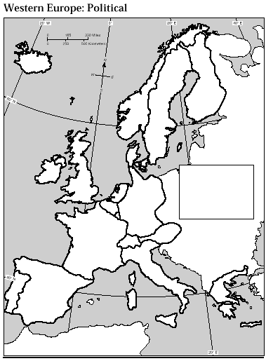
Shade & label the map with the following: England, Scotland, Wales, Ireland, Norway Sweden Finland
 | GEOGRAPHY | ECONOMY | CULTURE
ENGLAND
SCOTLAND
WALES
IRELAND
NORDIC NATIONS

