U.S. Territories & Basic Political Concept Name: ________________________________
Directions: Watch the video in the footer and take basic notes on the rights given to/restricted from citizens of each of the territories discussed. Label/find each on the maps to the left.

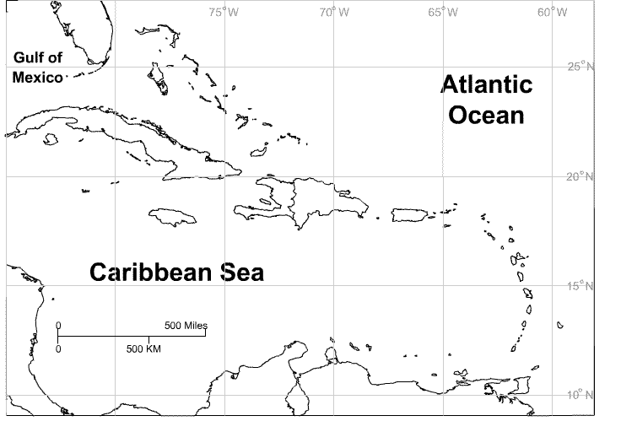
Puerto Rico:

Guam:

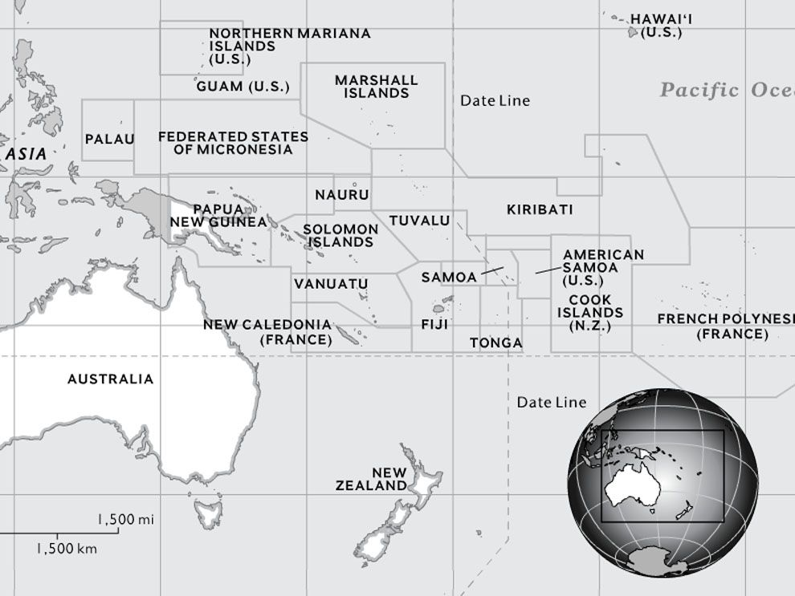

Samoa:

Key APHUG Terms:
Directions: Label the Venn diagram and label each circle with one of the following terms: “State”, “Nation” and “Nation-State”. Watch the video in the footer from 0:00-3:15 and take notes on each term. Include examples if provided.
