EuroNews
2.18.2014

When US President Barack Obama travels south of the border for the North American Leaders Summit in Toluca on Wednesday, he visits a country whose relations with the US are important and complex.
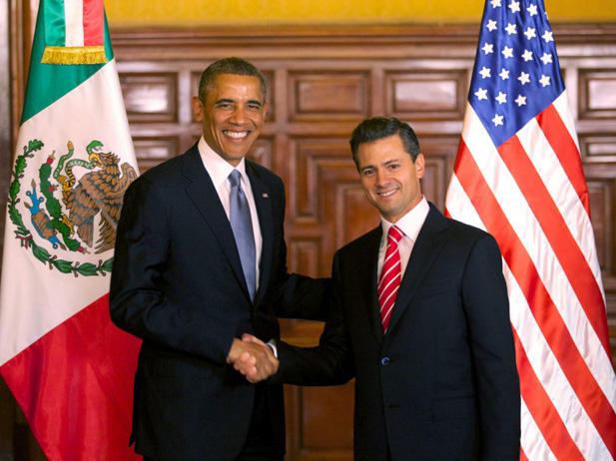
The two countries share a 2,000-mile border, and bilateral relations between the two have a direct impact on the lives and livelihoods of millions of people, whether the issue is trade and economic reform, homeland security, drug control, migration, or the environment.
The scope of US-Mexican relations is broad and goes beyond diplomatic and official contacts, and entails extensive commercial, cultural, and educational ties, with over 1.25 billion dollars of two-way trade and roughly one million legal border crossings each day.
In addition, a million American citizens live in Mexico. US tourists to Mexico numbered over 20.3 million in 2012 making Mexico the top destination of US travelers. Mexican tourists to the northern neighbor were about 13.4 million in 2011, and they spent some $9.2 billion.
Cooperation along the common border
Cooperation between the United States and Mexico along the common border includes state and local problem-solving mechanisms; transportation planning; and institutions to address resource, environment and health issues.
In 2010, a high level Executive Steering Committee for 21st Century Border Management was created to spur advancements in creating a modern, secure, and efficient border. The multi-agency US-Mexico Binational Group on Bridges and Border Crossings meets twice yearly to improve the efficiency of existing crossings and coordinate planning for new ones.
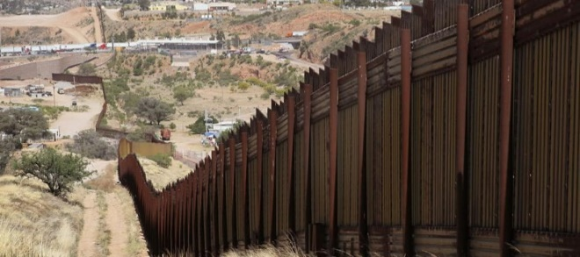
The ten US and Mexican border states are active participants in these meetings. Chaired by consuls from both countries, Border Liaison Mechanisms operate in “sister city” pairs and have proven to be an effective means of dealing with a variety of local issues including border infrastructure, accidental violation of sovereignty by law enforcement officials, charges of mistreatment of foreign nationals, and cooperation in public health matters.
Cooperation on environmental and natural resources issues
The United States and Mexico have a long history of cooperation on environmental and natural resource issues, particularly in the border area, where there are serious environmental problems caused by rapid population growth, urbanization, and industrialization.
Cooperative activities between the US and Mexico take place under a number of arrangements such as the US-Mexico Border 2012/2020 Program; the North American Development Bank and the Border Environment Cooperation Commission; the North American Commission for Environmental Cooperation; the Border Health Commission; and a variety of other agreements that address border health, wildlife and migratory birds, national parks, forests, and marine and atmospheric resources.
The International Boundary and Water Commission, created by a treaty between the United States and Mexico, is an international organization responsible for managing a wide variety of water resource and boundary preservation issues.
US security cooperation with Mexico
With the so-called “Merida Initiative”, both countries have established an unprecedented partnership to address violence and crime while strengthening the rule of law and the respect for human rights.
Since 2010, this cooperation has been organized under four strategic pillars. The first pillar aims to disrupt the capacity of organized crime to operate and the second pillar focuses on enhancing the capacity of Mexico’s government and institutions to sustain the rule of law.
The Merida Initiative’s third pillar aims to improve border management to facilitate legitimate trade and movement of people while thwarting the flow of drugs, arms, and cash. Finally, the fourth pillar seeks to build strong and resilient communities.
US cooperation with Mexico under the Merida Initiative directly supports programs to help Mexico train its police forces in modern investigative techniques, promote a culture of lawfulness, and implement key justice reforms.
Bilateral economic relations
Mexico is the United States’ second-largest export market (after Canada) and third-largest trading partner (after Canada and China). In 2012, two-way merchandise trade reached nearly $500 billion. Mexico’s exports rely heavily on supplying the US market, but the country has also sought to diversify its export destinations.
Nearly 78 percent of Mexico’s exports in 2012 went to the United States. In 2012, Mexico was the third-largest supplier of foreign crude oil to the United States, as well as the largest export market for US refined petroleum products and a growing market for US natural gas.
Top US exports to Mexico include electrical machinery, nuclear equipment, motor vehicle parts, mineral fuels and oils, and plastics. US companies have invested $101 billion in Mexico.
Mexican investment in the United States has grown by over 11 percent in the past year to $27.9 billion. It has grown by over 35 percent the past five years. Mexico is the seventh fastest growing investor country in the United States.
