US & Canada Regional Geography Group Project

Objective: The student will investigate the economic, social, and geographic features of a region of the US or Canada, and will report their finding to the class using a PowerPoint presentation.
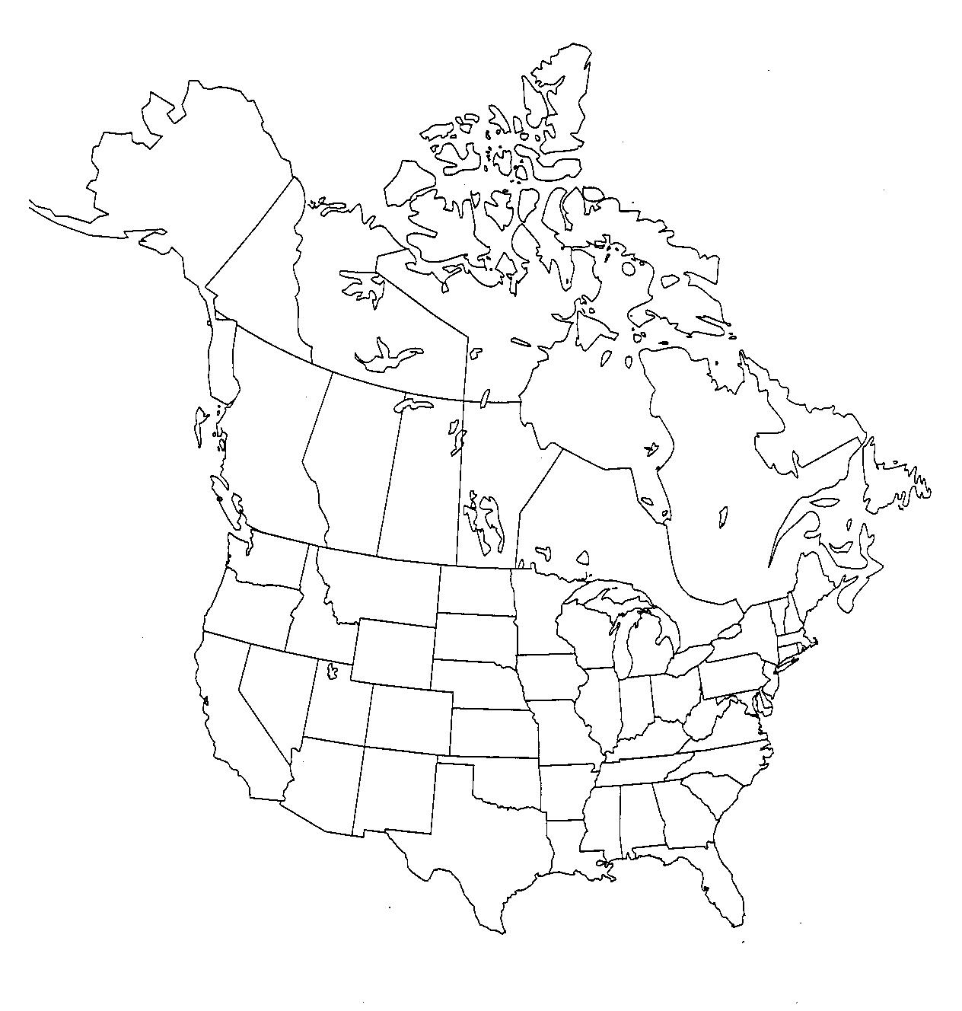

Procedure:
- Students will be assigned groups and each group will be assigned a region of the US or Canada.
- Students will research their assigned region, using the geography textbook and the Internet.
- Students will prepare a PowerPoint presentation using the rubric as a guide.
- Students will present their findings to the class.

Required Information:

Location
- location of region

Physical Characteristics
- physical features of the region, including mountains, major rivers, plains, coastline, ports, or other important features
- climates, vegetation of the region

Human Characteristics
- major cities, states/provinces
- population distribution (where most people live), number of people, migration (in or out, from or to where)
- historical immigration and settlement
- industry/economics (how do people make money)
- historical economy (what was the original economic base? Has it changed?)

Movement (connectedness) of People, Goods, and Ideas
- How are the people in this region connected to each other? (transportation systems, ports, etc)
- How is this region connected to (or isolated from) other regions?

Human-Environment Interaction
- any environmental/pollution issues

Required Visuals:

Maps: at least one for each section
- Location of region
- political, with major cities
- physical features
- population distribution
- economics

Pictures: at least 2 for each section
- major city
- major economic activity
- physical features
- iconic images from your region, ie – a cowboy from the West, Statue of Liberty, etc

Charts:
- climographs or rainfall/temp graph or map
US and Canada Regional Geography Rubric

CATEGORY | 9-10 | 8 | 7 | 0-6
content x3 | Thoroughly addresses all required criteria | addresses all 10 criteria | addresses at least 8 | fewer than 5 criteria addressed
visuals x2 | has more than the required 14 | has 14 visuals | has 10 visuals | has less than 10 visuals
accuracy | all information is accurately summarized | most information is accurate, but there may be 1 error | more than 1 error | many errors in accuracy
Duration of Presentation | Length of presentation was 4-5 minutes. | Length of presentation was 3-4 minutes. | Length of presentation was 3 minutes. | Presentation was less than 3 minutes long OR more than 5 minutes.
Clarity | Both visuals and audio crisp, clear, and understandable | Visuals or audio have parts that are not clear | Much material not clear or crisp | Much of the program not clear or understandable
Organization | Logical progression of information | Organization was ok | Little organization evident | No thought to organizing the information
Citations | All citations correctly formatted (MLA) | List of citations | Few citations | No citations

