CPR (Country Population and Refugee) Project

Directions:
Students will be participating in a project on the population/migration of a particular country compared to use United States. The presentation needs to be through an infographic, which you can make on Piktochart.com.

You will find a news article on your country that relates to refugees, whether it is a host or originating country. In order to do so, Google your country and the word “refugee”. Wikipedia articles will not be accepted as a news article, but can be used to gain background information.

There are two parts to this project
The Infographic will include the following information:
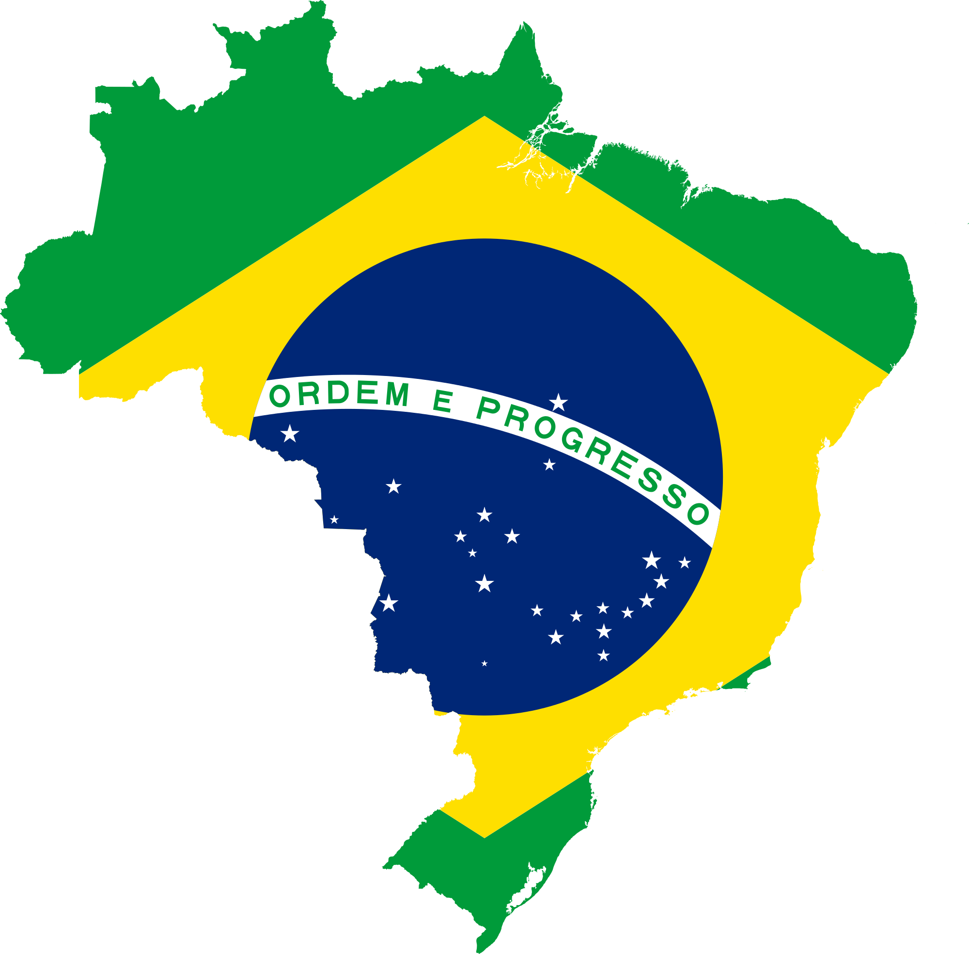
_______ General information (4 points)
Name and flag of your country
The region that your country is in (SE Asia, Central Am., etc.)
Isolated map of country (as shown on the right)
Fun fact!

_______ Population (8 points)
Population Pyramid
TFR
CBR/CDR
IMR
Life Expectancy
# of refugees emigrants or immigrants
2 Push or Pull factors (2 points)

_______ Current Event (8 points)
Article Titles
3 Main Points (3 points)

The rest of the projection will be graded on:

_______ Sourcing (5 points)
Cite all sources that you utilized and use the following website to source in MLA:
http://www.citationmachine.net/mla/cite-a-website
This document will be titled Bibliography and be stapled BEHIND the article

_______ Presentation (5 points)
You will present your infographic in 3-4 minutes. Notecards are required.

_______ Use of Time/Effort (5 points)
Misuse of class time will affect your grade. Is the project presentable

Resources you can utilize:

The UN Refugee Agency
http://www.unhcr.org/en-us/kenya.html

Population Data Sheet 2016
http://www.prb.org/pdf16/prb-wpds2016-web-2016.pdf

Population Pyramid
http://populationpyramid.net/

CIA World Factbook
https://www.cia.gov/library/publications/the-world-factbook/

The Guardian
https://www.theguardian.com/us

NPR
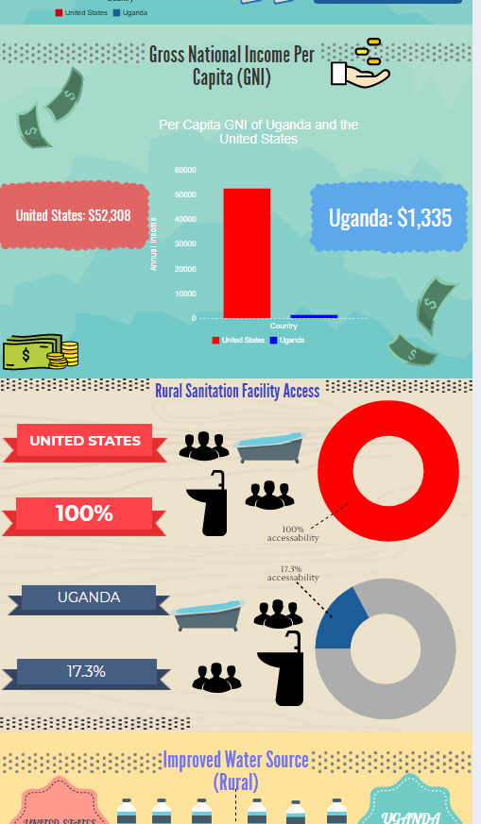
http://www.npr.org/sections/news/

The Economist
http://www.economist.com/
This is an AMAZING resource to find current events, however, some articles will be blocked off. If you think you have found one, I do have a subscription so ask me for help.

