POPULATION & CULTURE Name: __________________________________
Skim/preview through pages 87-98 and answer the end of chapter questions 2-4.
2. Which four regions have the world’s densest amount of people?
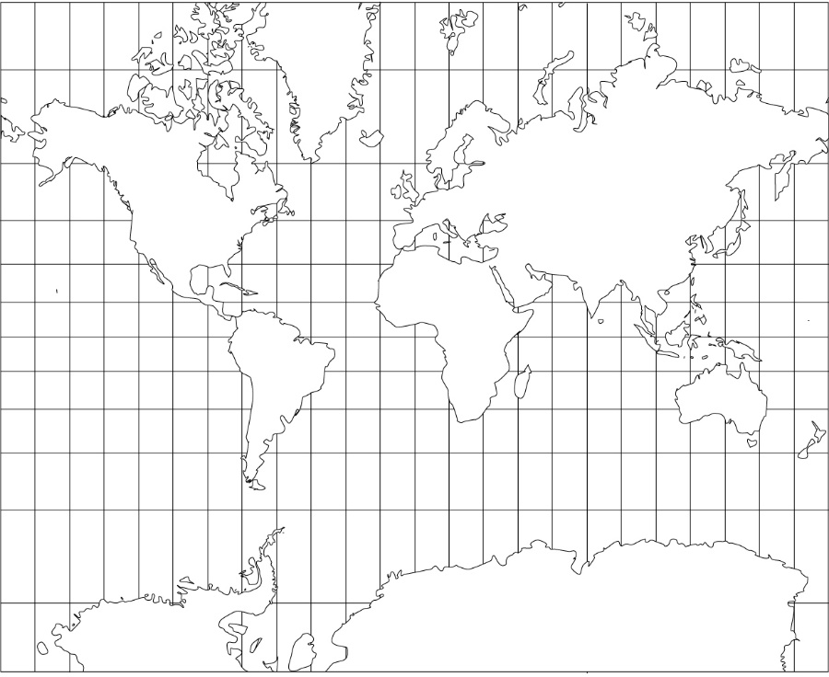

3. a. Why has population growth dramatically increased over the last few centuries?

b. What are some possible effects of population growth?

4. Make a list of many ways that cultures differ from each other.

POPULATION & CULTURE POWERPOINT REVIEW

