Land Area vs. Population
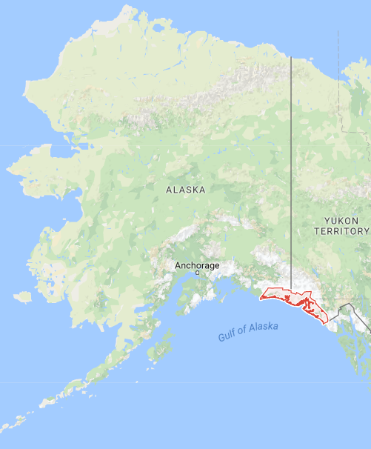
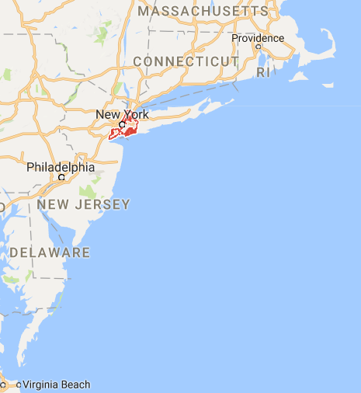
While New York City is the most populous city in the United States, Yakutat, Alaska is the largest city in area. Yakutat includes a whopping 9,459.28 square miles of area, comprised of 1,808.82 square miles of water area and 7,650.46 square miles of land area The city is larger than the state of New Hampshire (the country's 46th largest state). Officially known as the "City and Borough of Yakutat," the city consolidated the City of Yakutat Borough in 1992 to be the country's largest city.

Yakutat displaced Sitka, Alaska, which displaced Juneau, Alaska as the largest city. Sitka is 2874 square miles and Juneau is 2717 square miles (Sitka was the earliest large city, having been formed through incorporation of the borough and city in 1970).
Yakutat is a perfect example of an "overbounded" city, which refers to a city that has boundaries that extend far beyond its developed area (certainly the glaciers and ice fields in the city won't be developed soon.)
Here's the list, from New York City to San Antonio, of the largest metropolitan areas in the United States (based on mid-year 2006 population estimates from the ​U.S. Census Bureau)... 1) New York-Newark-Bridgeport, NY-NJ-CT-PA - 21,976,224 2) Los Angeles-Long Beach-Riverside, CA - 17,775,984 3) Chicago-Naperville-Michigan City, IL-IN-WI - 9,725,317 4) Washington-Baltimore-Northern Virginia, DC-MD-VA-WV - 8,211,213 5) Boston-Worcester-Manchester, MA-RI-NH - 7,465,634 6) San Jose-San Francisco-Oakland, CA - 7,228,948 7) Philadelphia-Camden-Vineland, PA-NJ-DE-MD - 6,382,714 8) Dallas-Fort Worth, TX - 6,359,758 9) Houston-Baytown-Huntsville, TX - 5,641,077 10) Atlanta-Sandy Springs-Gainesville, GA-AL - 5,478,667 11) Miami-Fort Lauderdale-Miami Beach, FL - 5,463,857 12) Detroit-Warren-Flint, MI - 5,410,014 13) Phoenix-Mesa-Scottsdale, AZ - 4,039,182 14) Seattle-Tacoma-Olympia, WA - 3,876,21115) Minneapolis-St.
U.S. Megolopolis’ & Census Data
French geographer Jean Gottmann (1915-1994) studied the northeastern United States during the 1950s and published a book that described the region as a vast metropolitan area over 500 miles long stretching from Boston in the north to Washington, D.C. in the south. This area (and the title of Gottmann's book) is Megalopolis. The term Megalopolis is derived from Greek and means "very large city." A group of Ancient Greeks actually planned to construct a huge city on the Peloponnese Peninsula.
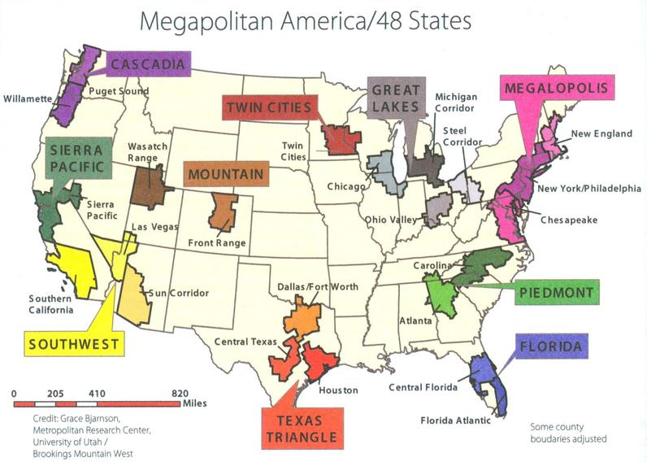
In the U.S. a northeast megalopolis has actually been developing over hundreds of years. It initially began as the colonial settlements on the Atlantic seaboard combined into villages, cities, and urban areas. Communication between Boston and Washington and the cities in between has always been extensive and transportation routes within Megalopolis are dense and have been in existence for several centuries.
When Gottmann researched Megalopolis in the 1950s, the census data defined many Metropolitan Statistical Areas (MSAs) in Megalopolis and, in fact, MSAs formed an unbroken entity from southern New Hampshire to northern Virginia.
In 1950, Megalopolis had a population of 32 million, today the metropolitan area includes more than 44 million people, approximately 16% of the entire U.S. population. Four of the seven largest CMSAs (Consolidated Metropolitan Statistical Areas) in the U.S. are part of Megalopolis and are responsible for over 38 million of Megalopolis' population (the four are New York-Northern New Jersey-Long Island, Washington-Baltimore, Philadelphia-Wilmington-Atlantic City, and Boston-Worcester-Lawrence).
Gottmann recommended that:
“We must abandon the idea of the city as a tightly settled and organized unit in which people, activities, and riches are crowded into a very small area clearly separated from its nonurban surroundings. Every city in this region spreads out far and wide a mixture of rural (country landscape), suburban (neighborhoods), and downtown city areas.”
Developing Megalopolis
Giant urban sprawl could pave over thousands of acres of forest and agriculture, connecting Raleigh to Atlanta by 2060, if growth continues at its current pace, according to a newly released research paper from the U.S. Geological Survey.
“We could be looking at a seamless corridor of urban development,” said Adam Terando, a research ecologist with the USGS and an adjunct professor at North Carolina State University who was the study’s lead author.
The development will engulf land from North Carolina to Georgia, and possibly spread to Birmingham, Ala., “if we continue to develop urban areas in the Southeast the way we have for the past 60 years,” he said. After analyzing the data for six years, Terando and his five co-authors estimated that urbanization in the Southeast will increase by up to 190 percent.It will nearly mirror the decades-old development of the Northeast corridor, from Washington to Boston.
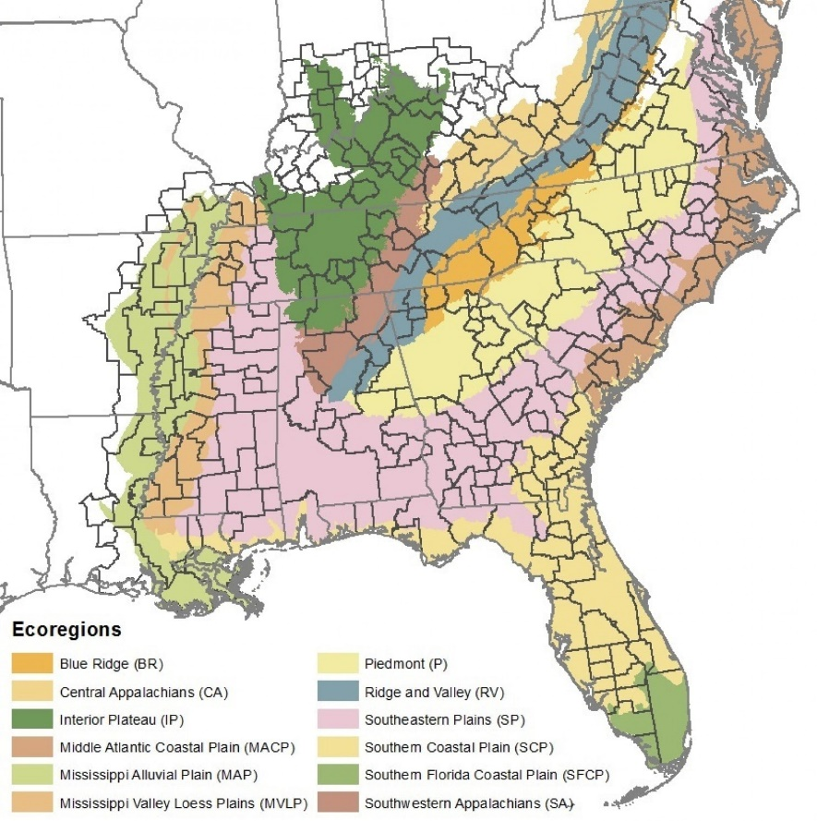
Development on that scale would result in losses of 15 percent of agricultural land, 12 percent of grasslands and 10 percent of forests, the study said. It would take the form of tract housing developments, business centers and thousands of miles of paved roads.The research paper also noted “There are large-scale human impacts on our environment . . . the way we develop.”
Numerous species of animals would be left with no habitat. The loss of woodlands that soak up rainfall would leave local waters more vulnerable to the storm-water runoff that washes nutrient pollution from lawns and motor oils from roads, in addition to increased garbage.
Carbon from automobile traffic down a more crowded Interstate 85 corridor would add to the ills contributing to climate change and the development of acid rain.
“The drawbacks are obviously things like more traffic,” Terando said. In Raleigh, there are a thousand miles of streets, and 2 percent to 3 percent must be repaved each year, according to the USGS, meaning more tax dollars will be needed to repair more roads.

