Mapping the U.S. Megalopolis Name: __________________________________ Per: _______
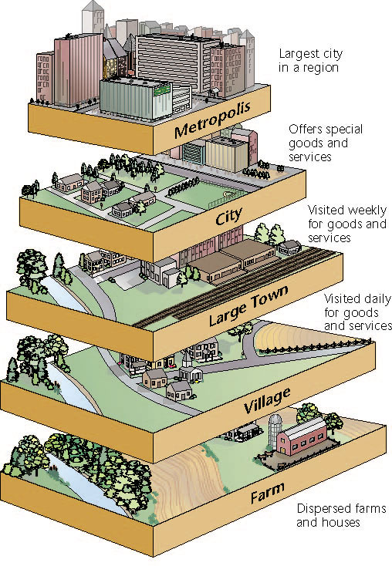
List all the differences between a city and a village that you notice in the picture.
Key Concept Connector: Define each term THEN rank them according to size by numbering them 1-3.

Metropolis

Metropolitan Area

Megalopolis

Read the 3 articles and answer the following questions:

1. What are the two largest cities in the U.S.? Explain how their size is different.

2. What is an “overbounded” city?

3. Make a list of the largest metro areas on the East & West Coast? Which coast has more?

4. What does megalopolis mean?

5. Explain how the U.S. northeast megalopolis developed? What was a major factor?

6. How much of the U.S. population lives in this megalopolis?

7. Where is the newest developing megalopolis?

8. What potential negative impacts will the new megalopolis have on the environment?

