MAPPING REVIEW Name: ________________________________
Period: ________
1. Label the lines of latitude and longitude on the map.
2. Use a colored pencil to draw in the equator, prime meridian, and International Date Line.

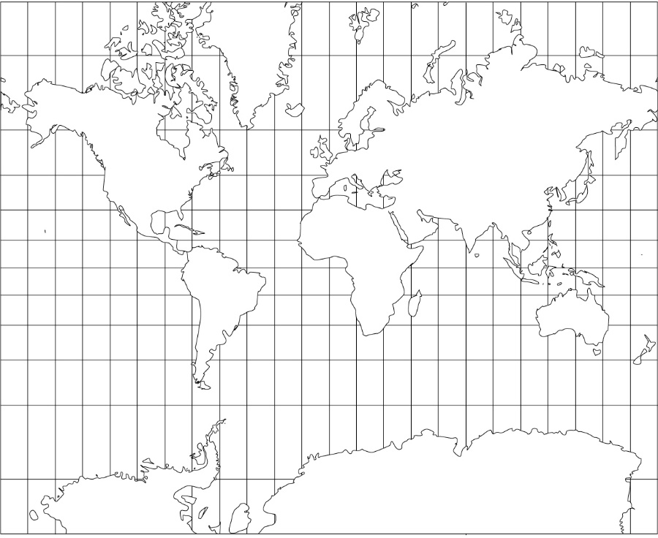

Answer the following questions while watching the video.
3. What is the name of this map projection (type of map)?
4. When was it designed?
5. What was it specifically designed for?
6. What’s wrong with this map?
7. How do you think maps shape our view of the world? Explain.
TYPES OF REGIONS

Read the examples below and decide if they are formal, functional, or perceptual regions. Write the correct choice in the blank.

State of Nebraska _______________
Commuter zone _______________
The southern U.S. _______________
I-5 Corridor _______________
Mexico _______________
School district _______________
Seahawks season ticket holders _______________
The U.S. Midwest ________________
“Walking distance” ________________

