CHAPTER # 5 - UNIT #3
What is unique about Quebec’s official language compared to the rest of Cananda? Why did this happen?

What do the countries on the map below have in common?

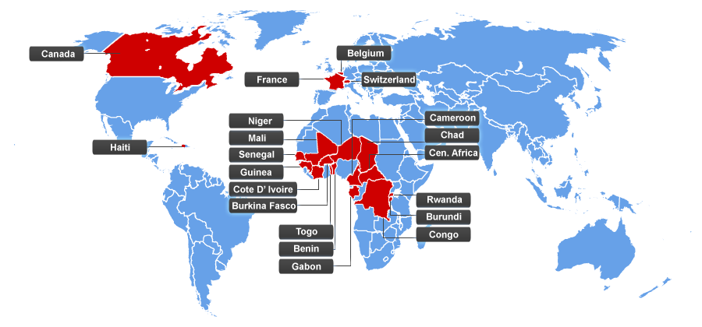
What do the countries on the map below have in common?

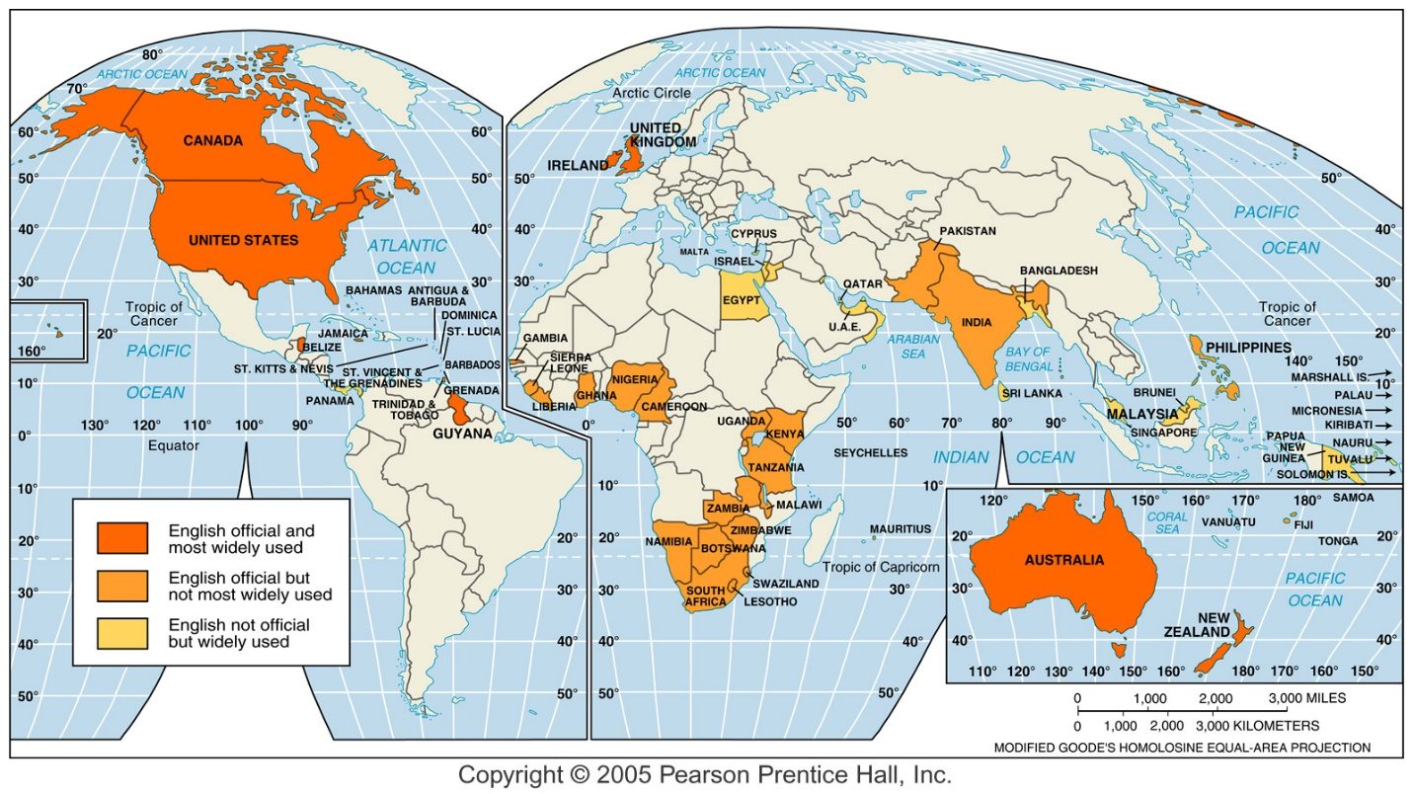
What 4 groups invaded the British Isles and contributed to the development of English?

Use powerpoint or page #139 in textbook to draw arrows that show the invasions of the British Isles. Either label clearly or create a map key. Label key states (modern day).
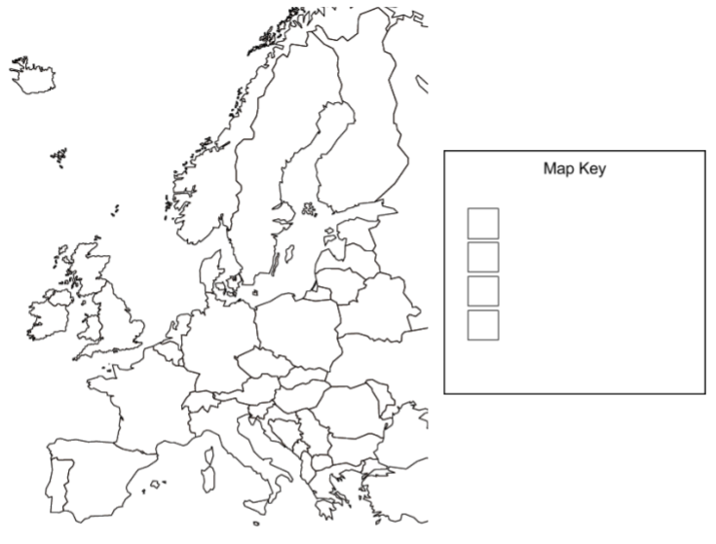
Where did modern day english simple words come from?

Where did modern day english “fancy” words come from?

What is a dialect?

Sketch (approximate) & label the different regional dialects in the United States.

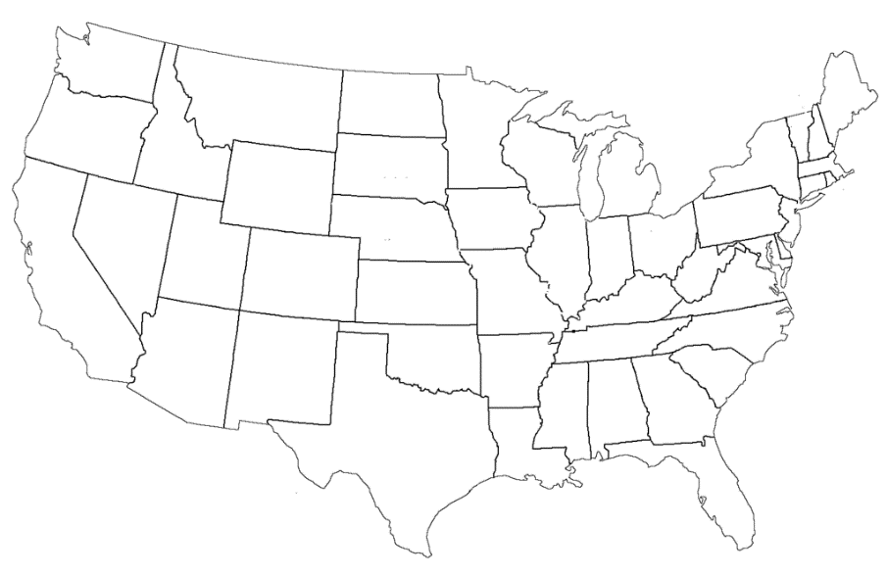
Describe the development of European Languages using Renfrew’s theory.

How did other branches of language develop?
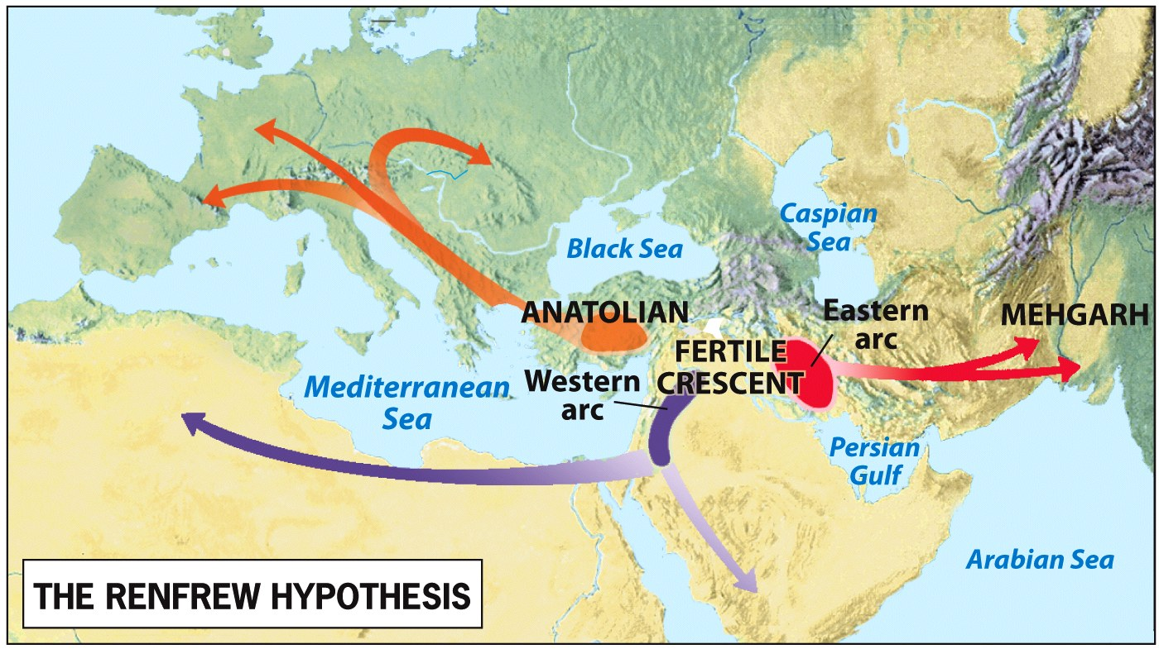

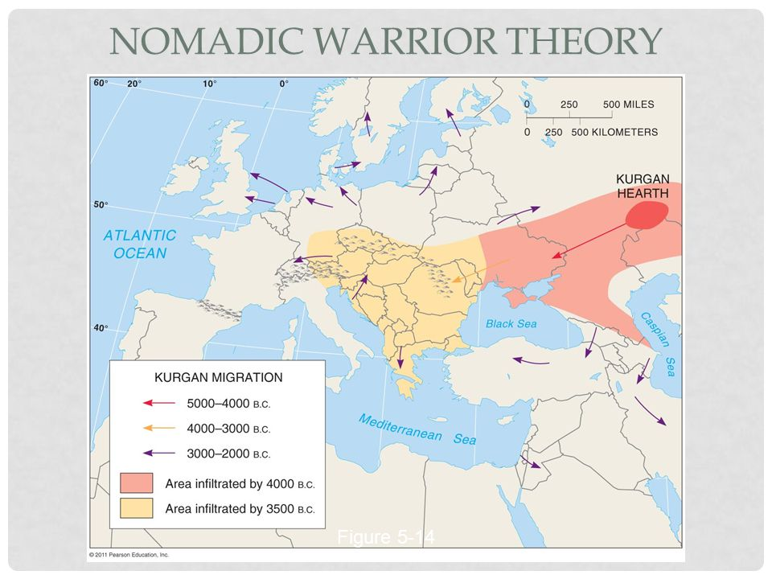
Where did language originated according to the Nomadic Warrior Thesis?

Describe its movement.

Chapter #5 (Language) – Unit #3 Packet (continued)
What is backward reconstruction of language?

What are the 3 major language sub-families (branches) of Europe (Indo-European Language Family)? Circle & label on map below.

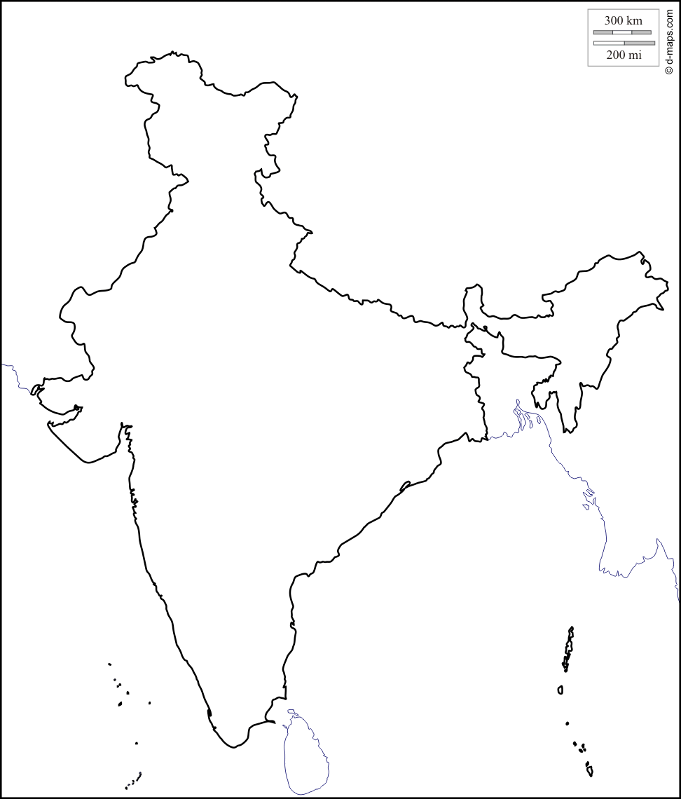
Which 4 language families are represented in India? Circle & label on map below.

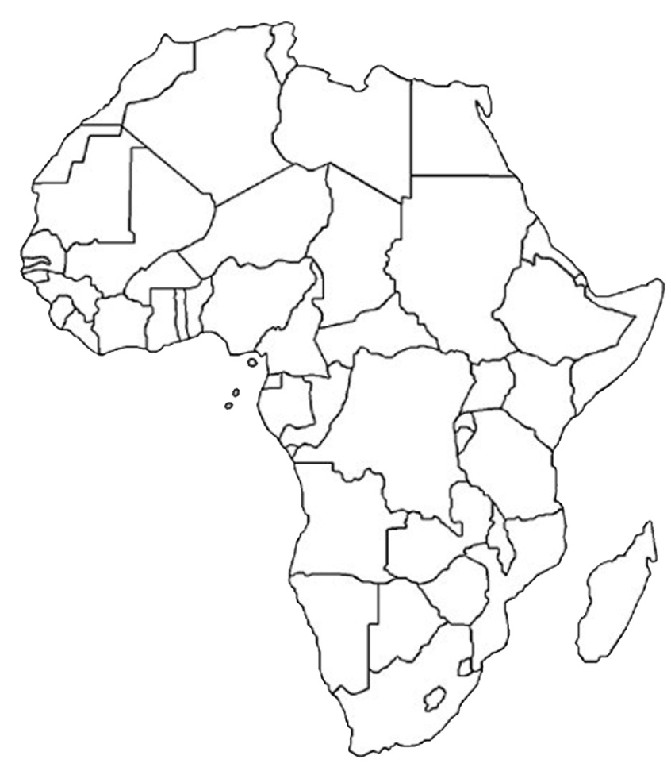
Use the map of Africa to the right for the following questions:
Lightly shade the Sahara desert.
Draw an “X” on the hearth of African Rice (Niger River).
Find & label South Sudan.
Find & label Congo.
Find & label South Africa.

Draw a circle around the areas that speak each language family on the map. THEN under each family, write a tip to help you remember their location in Africa (Hint: use directions above.)
- Indo-European

- Afro-Asiatic

- Niger-Congo

- Saharan

- Sudanic

- Khoisan

- Austronesian
Use the following words & numbers to complete the table below. Textbook pages 154-155.

- English
- Malay-Polynesian
- 125
- Indonesian
- Altaic
- 445
- Korean
- Japanese
- Sino-Tibetan
- Telugu
- 32
- Spanish
- Hindi
- Japanese-Korean
- 78
- Chinese
- Arabic
- 61

Language Family | Major Language | Numbers (in millions)
Indo-European
 |  | 366
 |  | 340
 |  | 1,211
 | Burmese
Afro-Asiatic |  | 211
 |  | 154
Dravidian |  | 69
 | Turkish

Use pages 152-153 in textbook to color the map below. Don’t forget to complete the key.
