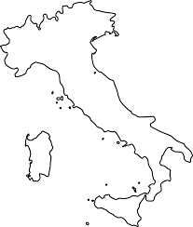
Regions of Italy Name: ____________________________________

