MAPPING THE IMPACT OF HURRICANE HARVEY Name: ____________________________________
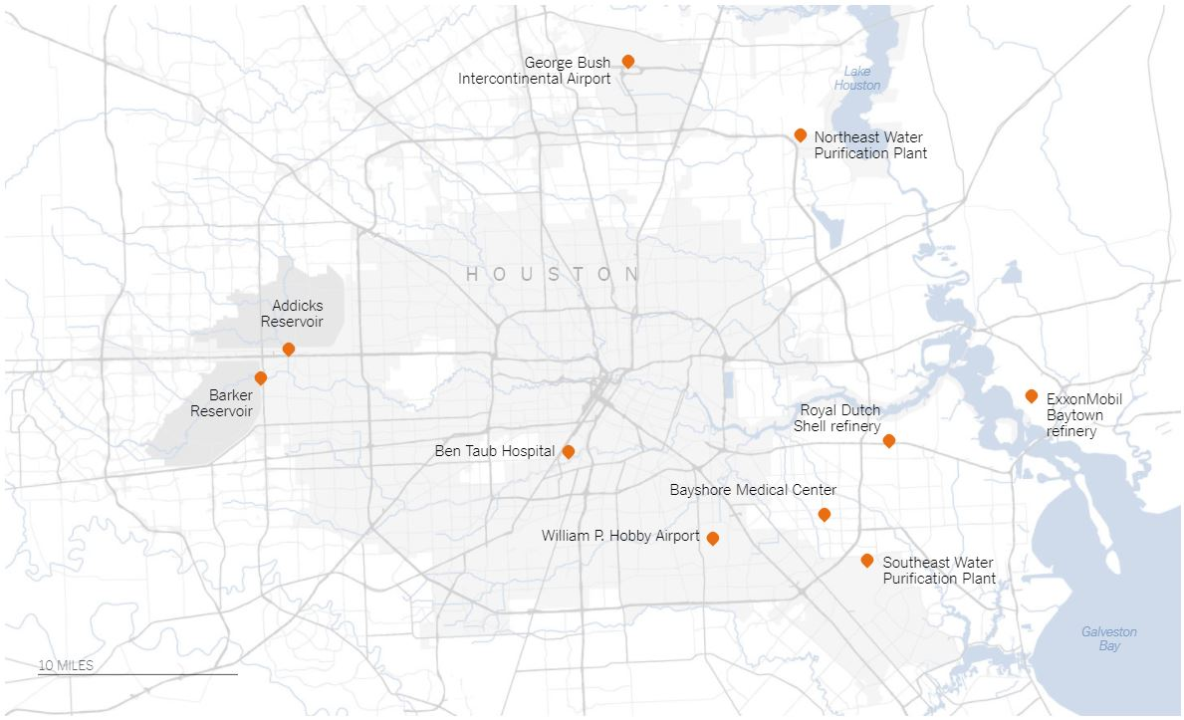 | Closed Infrastructure
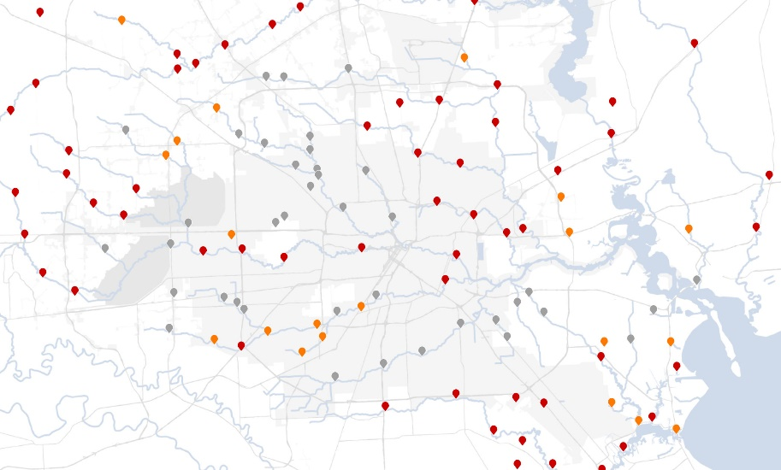 | Additional Water Overflow
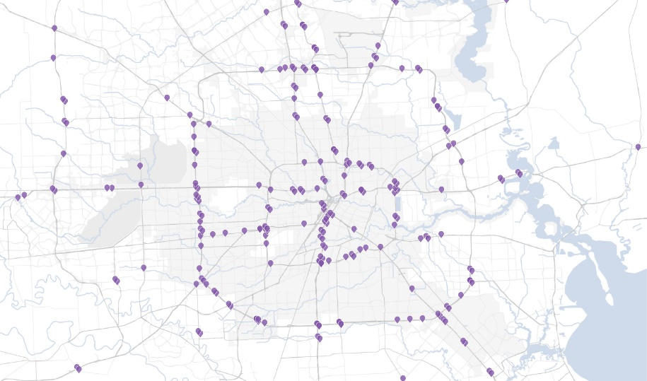 | Closed Roads
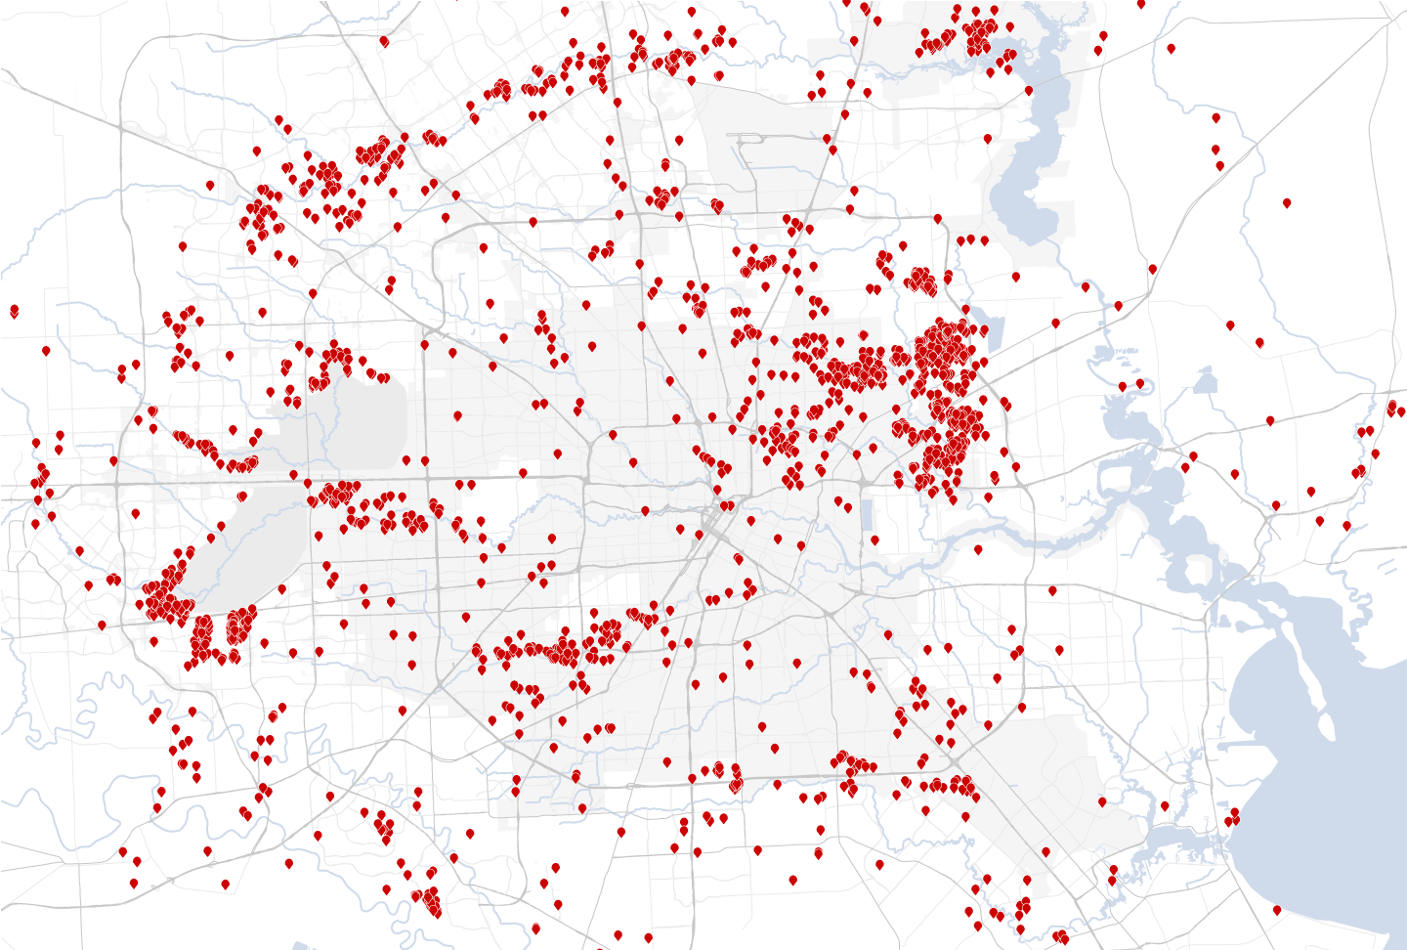 | Rescue/Aid Requests
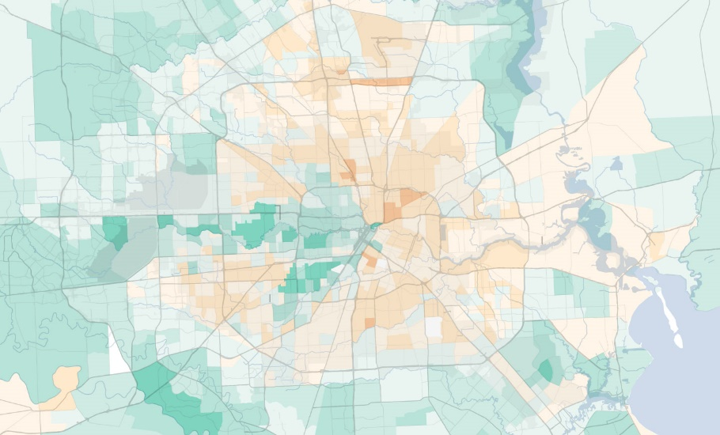 | Income Map
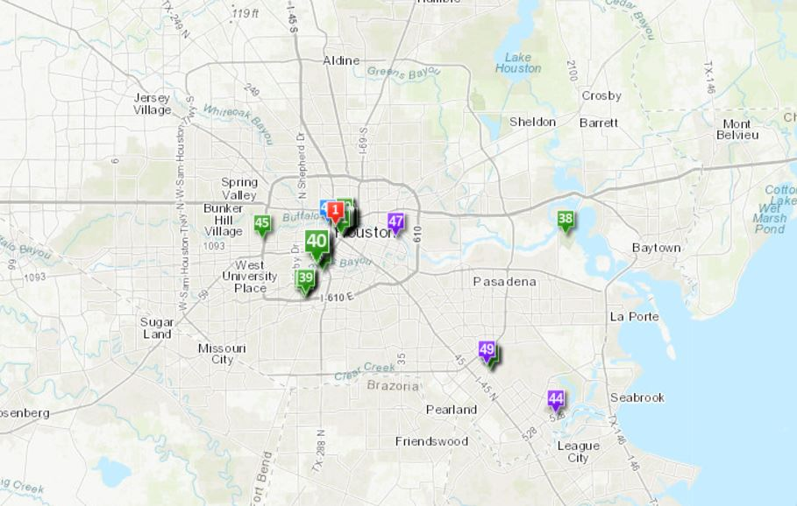 | Events & Historical Places
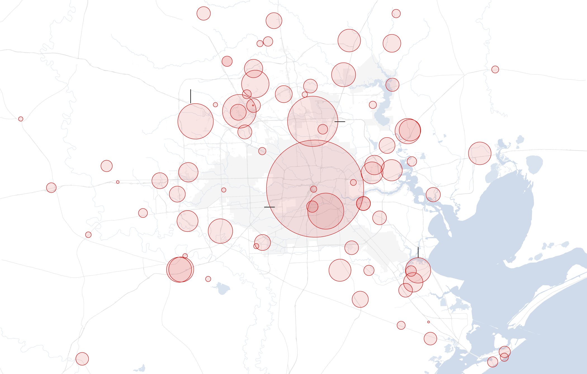 | Displaced to Shelters

CONCLUSION:
Pretend that you work for the government and are in charge of providing resources. Use this information to create a plan of action for providing aid and a report about the lasting impacts on the city.

Once you decide what resources should go where, decide on the best places to stage your resources. The staging locations need to be cities that are large enough to support the people and vehicles being sent in. Resources need to be close enough to get to people quickly, but not so close that they are damaged/destroyed by the storm, too.

