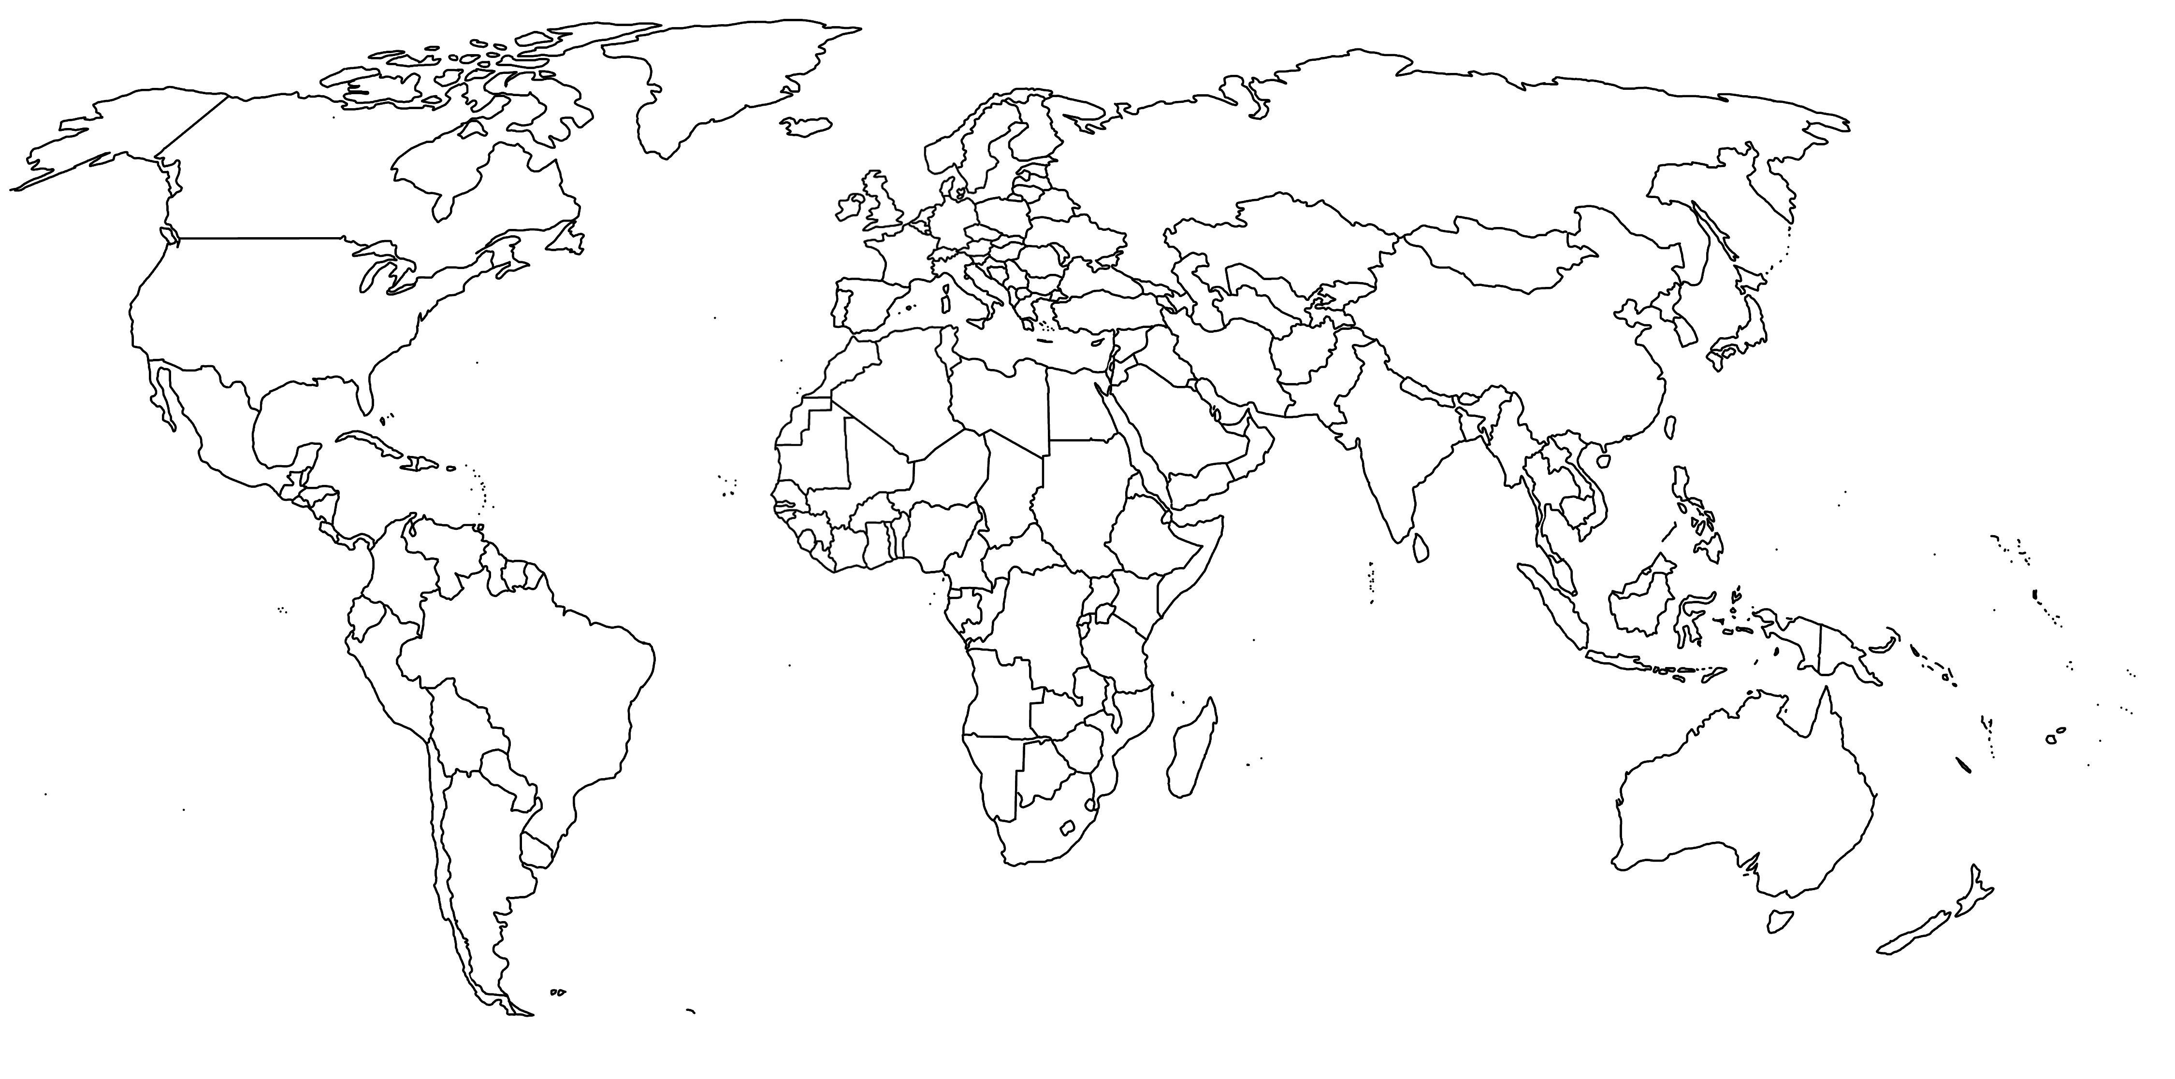
HISTORIC MIGRATION EXAMPLES
Label each region / migration from flipside of paper
Afgani (after Soviet Invasion)  Who:  When:  Why:  Push/Pull: | Romani People  Who:  When:  Why:  Push/Pull: | Jews (20th century- Palestine)  Who:  When:  Why:  Push/Pull:
Vietnamese “Boat People”  Who:  When:  Why:  Push/Pull: | U.S. African Americans  Who:  When:  Why:  Push/Pull:

