Name: ______________________________
THE PROBLEM WITH GERRYMANDERING
Gerrymandering is: ______________________________________________________________________________________________________________________________________________________________________
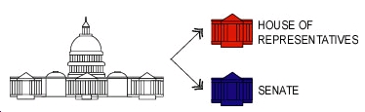
- Both the United States Legislative branch AND each state’s legislative branches are divided into two voting bodies (groups).
  - There are ______ members in the U.S. Senate (____ per state)
  - There are ______ members in the U.S. House of Representatives (numbers decided based on each state’s _______________)
A “Simple Majority” is:
- Congressional representatives (people in the House of Representatives or the Senate) must be elected by a ____________ ____________________ in their voting district.
- Most bills (which become _______) muse be approved by a ___________ _________________
- Two methods used to sway an elections when a state re-draws election districts
  - Packing is:

  - Cracking is:

