VIDEO QUESTIONS:
TRANSPORTATION HISTORY REVIEW: label each transportation network with dates if applicable.
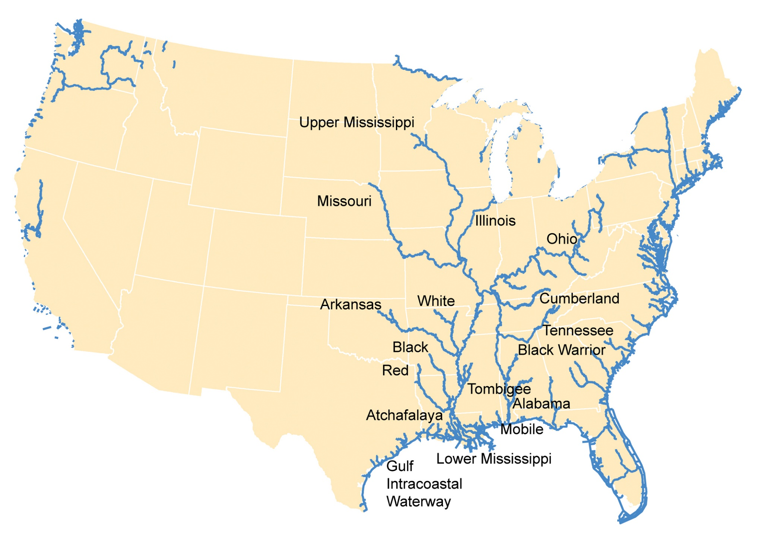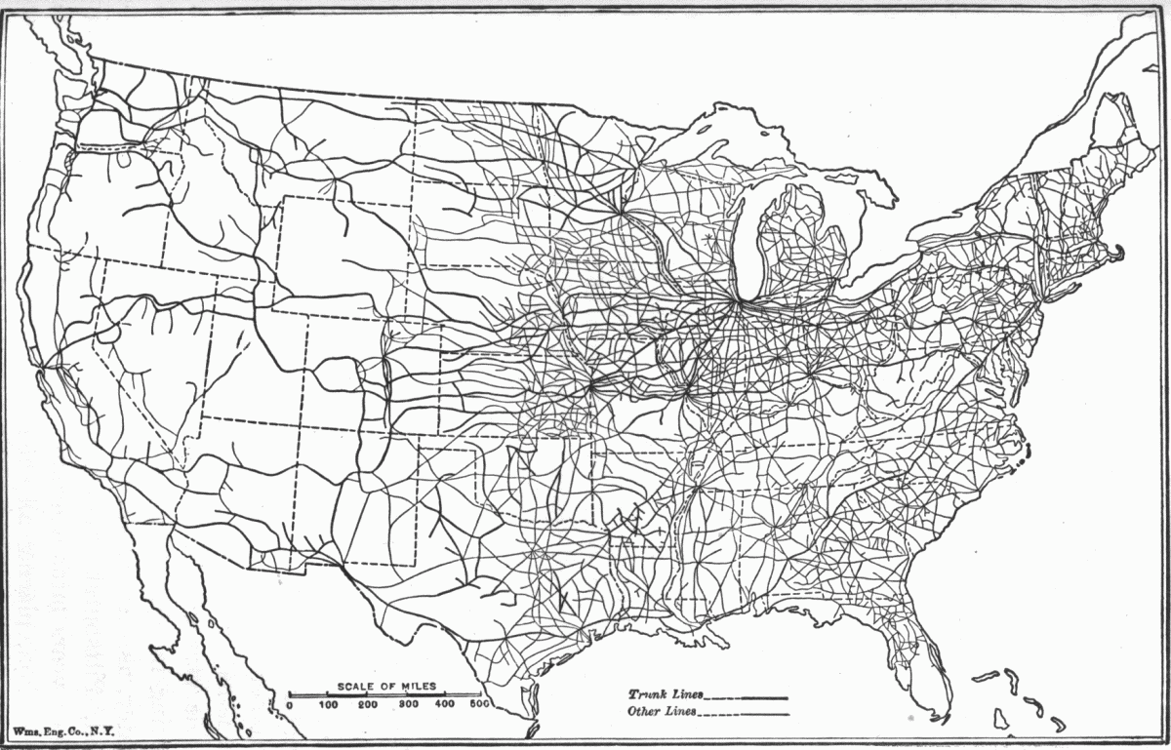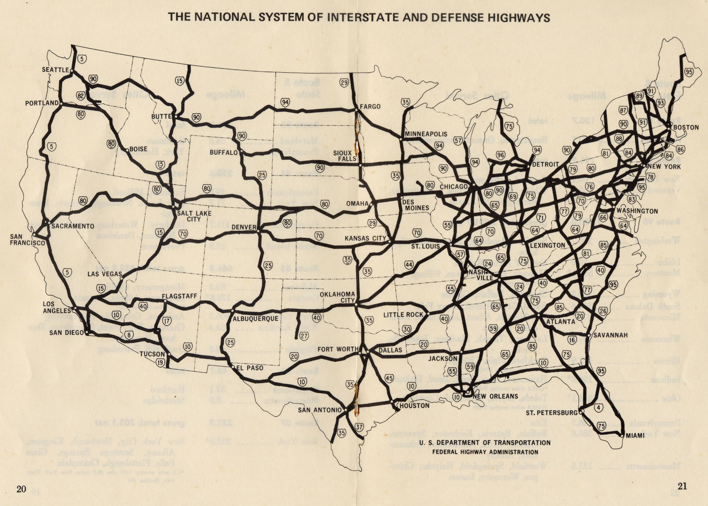

Test Prep: All major cities during the first 50 years of independence were located:
a. near the Great Lakes b. along the Erie Canal
c. along the Mississippi River d. Along the Atlantic Coast

- What obstacle did the east coast face in expanding civilization into the western U.S.?

- Where does the erie canal start/finish? (city, region).

- How deep was the canal? How much were first workers (farmers) paid to work on the canal?

- List 3 natural obstacles the canal builders encountered?

- What was “the wedding of the waters”?

- How did the price of transporting goods (per ton) change because of the canal?

- What goods were brought from the west to east? East to west?

- Why did some people dislike the canal?

- When boats on the canal change from being pulled by mules to powered by steam and electricity?

- When did the canal become “dead” or unused?

- How were the pattern of railroads and highways similar to the canal?

