Corn Pantry Scavenger Hunt Name: ___________________________________
Pantry | Corn Syrup | Dextrin/ Malodestrin | Caramel Color | Asorbic Acid | Corn Starch | Saccharin | Dextrose | Iodized Salt | MSG | Xanthan Gum | Sorbitol/ Sorbitan | Citrate | Polysorbate
Candy & Baking | Xylitol | Corn Syrup | Corn Starch | Saccharin | Dextrose | Sorbitol/ Sorbitan | Ethanol | Baking Powder | Citrate
Bathroom/ Medicine | Xylitol | Corn Starch | Decyl Glucoside | Methyl Gluceth | Lauryl Glucoside | Zein | Sorbitol/ Sorbitan

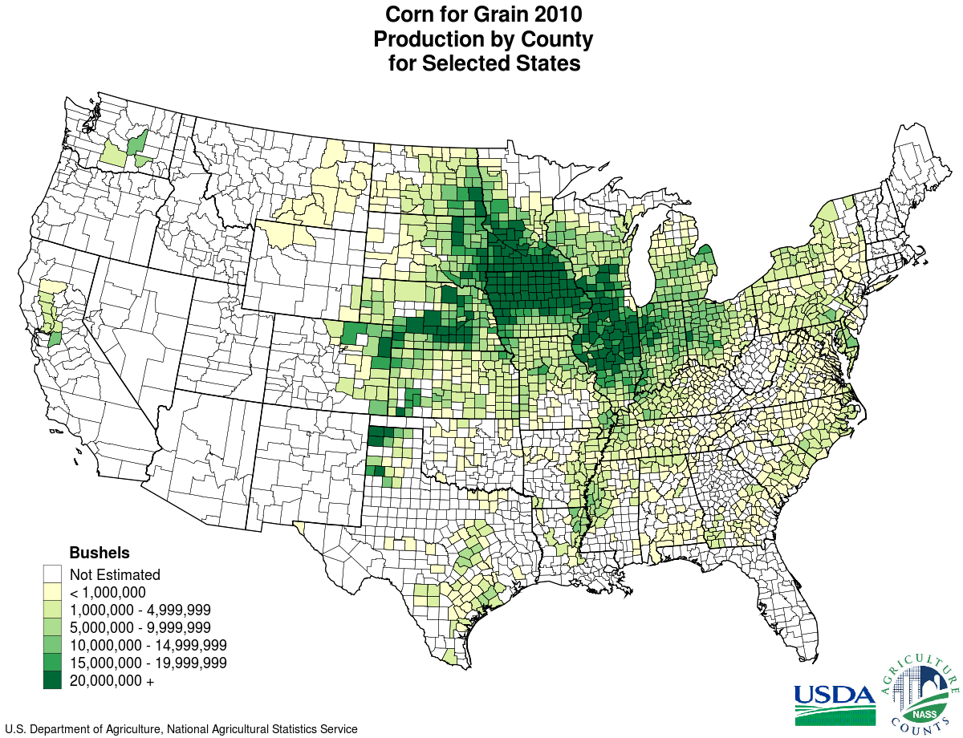
- What was the most surprising product that contained a corn product/derivative?

KING CORN Movie Questions
- What is the farm program for corn called? How much are Curt & Ian Paid for their 1 acre of corn?

- How many acres of corn do most farmers in Green, Iowa grow?

- How much more corn can farmers with ammonia fertilizer grow?

- How are most cattle in the U.S. raised? What is the driving force behind corn-fed cattle instead of grass-fed cattle?

- When did corn syrup and corn starch become popular in the U.S.? What are their culinary benefits?

- What percent of crops are used for ethanol? What is ethanol used for?

KING CORN Movie Questions

- What is the farm program for corn called? How much are Curt & Ian Paid for their 1 acre of corn?
$28
- How many acres of corn do most farmers in Green, Iowa grow?
1,000 acres
- How much more corn can farmers with ammonia fertilizer grow?
Four times as much corn because it grows faster.

- How are most cattle in the U.S. raised? What is the driving force behind corn-fed cattle instead of grass-fed cattle?
50% of corn in the U.S. is fed to animals.
Most cattle are raised on feedlots.
Profit. Corn-fed cattle require less money and less space than grass-fed cattle.
- When did corn syrup and corn starch become popular in the U.S.? What are their culinary benefits?
Late 1980’s. It enhances flavor, lessens acidic taste of foods gives, and provides a great browning value to foods helps, it also helps to thicken gravy

- What percent of crops are used for ethanol? What is ethanol used for?
32%

