1. Cut out the following pictures and glue them into the correct region (2 of the same pictures = two different regions)
2. Write 1 sentence under the picture with a specific piece of information (about the picture) from your textbook
3. Write the following statements in the category they fit into
- Settlers were first attracted to this area because of its rich soil and mild climate
- Aqueducts are in this region
- This area produces the most grain, dairy, and hogs
- Business moved to this area because of cheap land, new industrial plants, and labor unions were less common
- This area is known as the nation’s breadbasket
- This area is a megalopolis and has a trash disposal problem because of its high population
- Forestry & fishing are important in this region
- Mangrove trees are found in this region

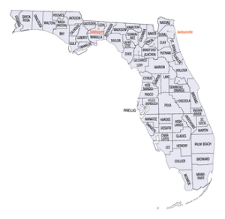
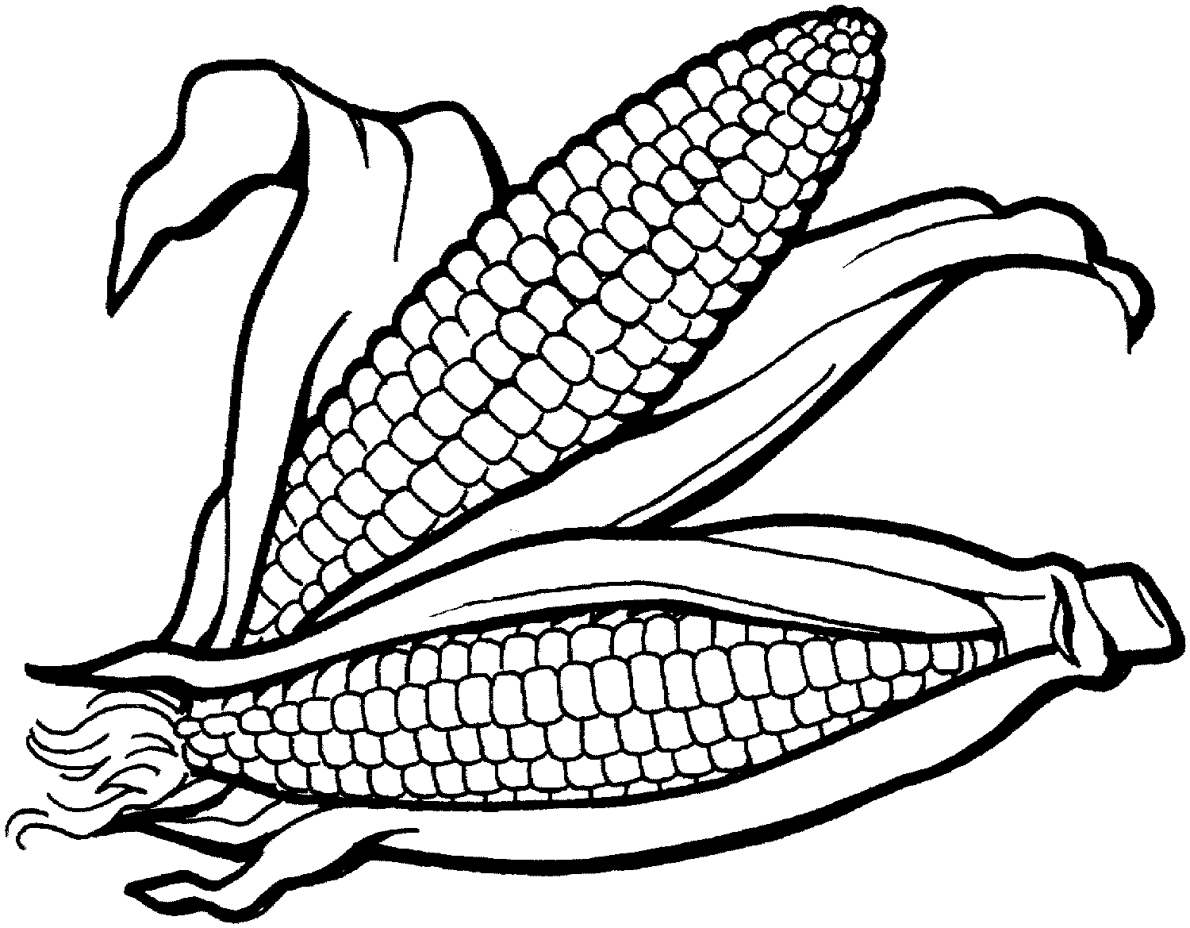
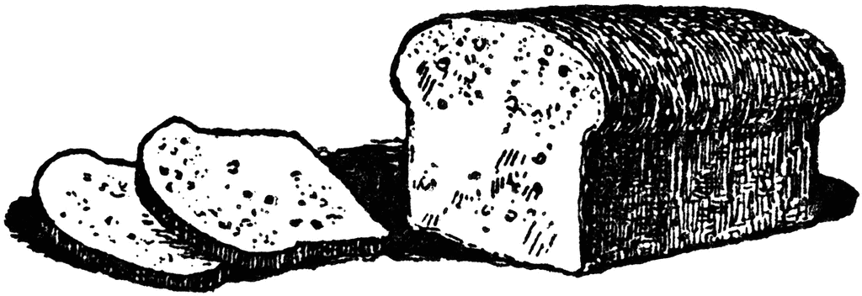

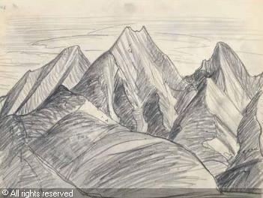
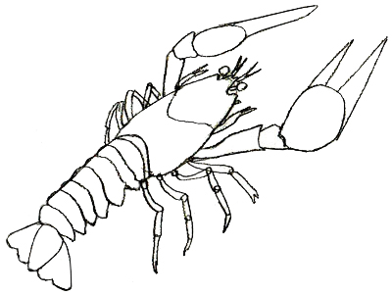
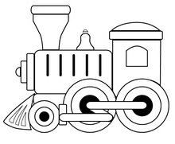
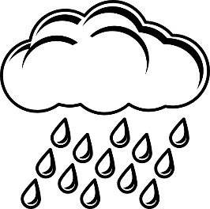
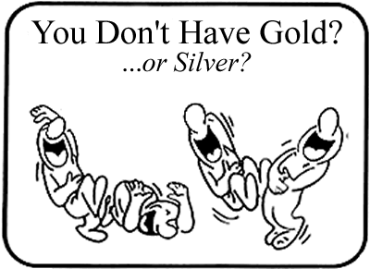
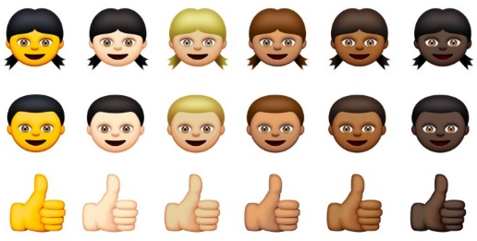

The South | The West
The Northeast | The Midwest

