**Key Issue 1: How Do Geographers Describe Where Things Are?**

***Pages 5-13***

*\*\*\*Always keep your key term packet out whenever you take notes from Rubenstein. As the terms come up in the text, think through the significance of the term.*

1. Define ***map:***
2. What is the science of mapmaking called?
3. What are the **two** purposes that maps serve?
4. Who first used the term “geography”?
   1. What does the term “geography” mean? (You may have to look it up!)
5. Provide examples of developments in geography for each of the following:

|  |  |
| --- | --- |
| **Chinese** |  |
| **Muslims** |  |
| **Age of Discovery (16th Century)** |  |

1. Define ***scale:***
   1. What is the advantage of a map which shows only a small portion of the earth’s surface – like a neighborhood – that is, a ***large-scale map***?
   2. What advantage does a map which shows the entire globe, a ***small-scale map***, have?
2. When geographers convert the round Earth to a flat map, they use a **projection.** All projections have some distortion (only a globe has none). List the **four** things that typically become distorted in various projections and explain the distortion.
3. Two important projections are the **Mercator** and the **Robinson.** Complete the chart below to compare their advantages and disadvantages.

|  |  |  |
| --- | --- | --- |
|  | **Mercator** | **Robinson** |
| **Advantages** |  |  |
| **Disadvantages** |  |  |

1. What place is designated as 0 degrees longitude?
2. What is the name for the line drawn at 0 degrees longitude?
3. What is the name for the line drawn at 0 degrees latitude?
4. How is a degree of longitude or latitude further subdivided?
   1. Give an example.
5. How many degrees of longitude do you need to travel across to pass through one “hour” of time (or one time zone)?
6. How many time zones are there?
7. Using an outside source, find out which country first adopted time zones and when that occurred.
8. What is the longitude of the International Date Line?
9. Use page 11 and the information in the reading to annotate the map below.
   1. Draw the **Prime Meridian** and **International Date Line.**
   2. Label the country that moved the International Date Line in 1997.

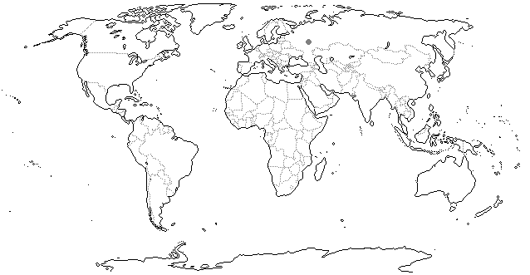

1. Define ***remote sensing:***
2. List several things that geographers can map using remotely sensed data.
3. Complete the following regarding a ***Global Positioning System***

|  |  |
| --- | --- |
| Elements/Components | Uses/Implementation |
|  |  |

1. Geographers use **GIS** (Geographic Information System) to store “layers” of data. Give **four** examples of types of data stored in a single layer.
2. Explain a ***mashup*** in relation to geography and GIS.

**Key Issue 2 (Part #1): Why Is Each Point on Earth Unique?**

***Pages 13-20***

1. Each place on earth is ____________________ and also ____________­­___________ the combination of these two factors is what geographers study to understand why things are where they are.
2. Every point on earth is unique because of _____________________ and _____________________. What is the difference between these two factors?
3. Use the chart to label four ways to identify location.
4. Identify **four** ways in which places can receive names
5. Define ***site:***
6. List some ***site characteristics:***
7. Define ***situation:***
8. Think of a creative way that you and your classmates can remember the difference between site and situation! We’ll vote on the best idea!
9. A ***region*** is an ____________________ of ______________________ defined by one or more

__________________________.

1. One contemporary (current) approach to studying the cultural landscape is called the ***regional studies approach.*** What do geographers who adopt this view believe regarding regions?
2. Complete the chart below which details types of regions identified by geographers:

|  |  |  |  |
| --- | --- | --- | --- |
|  | **Formal Region** | **Functional Region** | **Vernacular Region** |
| Also Called |  |  |  |
| Definition |  |  |  |
| Example |  |  |  |

**Key Issue 2 (Part #2): Why is Each Point on Earth Unique?**

***Pages 21-28***

1. A. What does the section titled “spatial association” tell us about the different conclusions you might draw about cancer in the U.S. as a whole compared to cancer at a state scale?

B. What does this tell us about the importance of scale overall?

1. What **two** meanings of culture do geographers study? Briefly describe each.
2. Define the terms ***MDC*** and ***LDC:***
3. List 3 ways impacts to human geography can be seen in hurricane destruction (such as Katrina & Harvey).
4. Complete the diagram with notes about cultural ecology:

|  |
| --- |
|  |
|  |



**ENVIRO. DETERMINISM**



**POSSIBILISM**

1. Who developed the system that divides the world into 5 climate regions? What is this system called?
2. Label/shade/color the world map below with the 5 climate regions.

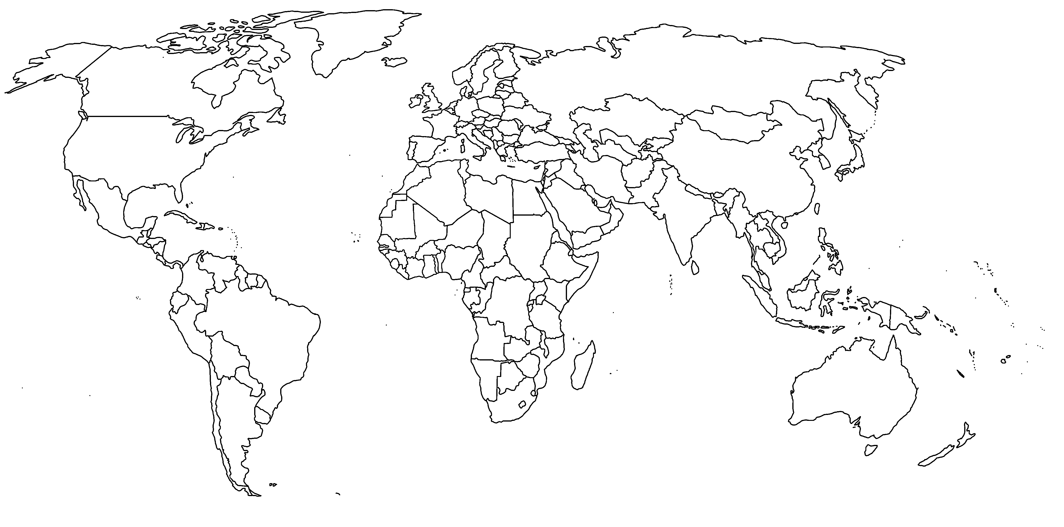

1. What climate region is India’s SW Coast? In what ways do humans depend on the environment in this region?
2. A. What **two** things influence biomes?

B. What **one** human processes do biomes influence most?

10. Bullet the basics of each biome:

|  |  |  |  |
| --- | --- | --- | --- |
| **FOREST** | **SAVANNA** | **GRASSLAND** | **DESERT** |
|  |  |  |  |

11. Erosion significantly impacts farmers in MDC’s & LDC’s. How does each group handle Erosion?

12. Does the development of technology provide a greater argument against possibilism or environmental determinism? Why?

13. Be able to describe the ***causes*** of environmental modification and their ***impacts*** in the Netherlands & the Everglades.

|  |  |  |
| --- | --- | --- |
|  | **CAUSE/PROBLEM** | **IMPACTS** |
| **FLORIDA** |  |  |
| **NETHERLANDS** |  |  |

**Key Issue 3: Why Are Different Places Similar?**

***Pages 29-40***

1. Geographers “think and act both global and local”. Why is scale important? (What can you see at a local scale vs. a global scale?)
2. Define ***globalization:***
3. What technologies influence the spread of globalization?
4. In a globalized economy, each place is specialized. Explain this concept:
5. How was the recession that began in 2008 an example of globalization?
6. Use the table to make a list of the ways culture is either “uniform” (the same) or “unique” in today’s globalized world:

|  |  |
| --- | --- |
| **Uniform Cultural Traits/Examples** | **Cultural Differences** |
| * *Worldwide people want to own/drive a car* | * *TV programs can be tailored to a specific culture/language anywhere in the world.* |

1. The __________________________ of a feature in ______________________ is known as its **distribution.**
2. Complete the chart below with notes/examples for each type of geographic distribution:
3. In the boxes below, draw 10 dots in each so that the **density** is the same in each, but illustrate and label the two different kinds of **concentration**.

|  |  |
| --- | --- |
|  |  |

1. Why do geographers consider cultural identity to be important in understanding special interaction?
2. Describe **space-time compression:**
3. Describe the phenomenon known as **distance decay**.
4. ***Diffusion*** is defined as the process by which a characteristic spreads across space. With regard to diffusion, define and, where possible, give an example of each of the following:

|  |  |  |
| --- | --- | --- |
|  | **Diffusion** | |
|  | **Hearth** |  |
|  | **Relocation Diffusion** |  |
|  | **Hierarchical Diffusion** |  |
| **Expansion**  **Diffusion** | **Contagious Diffusion** |  |
|  | **Stimulus Diffusion** |  |

1. In the past, most interaction between places required what?
2. What is **space-time compression?**
3. How has interaction between places changed? (think **networks**)
4. Give some examples of things that retard interaction among groups.
5. Global culture and economy are increasingly centered in the 3 core (**hearth**) regions of:







1. What are the **three** major reasons for these three areas being **hearths**?



1. Explain why there is an increasing economic gap between regions in the world. (AKA: **uneven development**).

**Key Issue 4: Why Are Some Human Actions Not Sustainable?**

***Pages 30-37***

1. Explain the difference between **renewable resources** and **nonrenewable resources.**
2. What are the **two** major misuses of resources geographers observe?
3. Define ***sustainability:***
4. In the table below, explain and give a bulleted list of details about each of the **pillars of sustainability**

|  |  |
| --- | --- |
| **3 Pillars of Sustainability** | |
| **Environment** *(focus on* ***conservation*** *vs.* ***preservation****)* |  |
| **Economy** |  |
| **Society** |  |

1. Explain **two** major criticisms about sustainability
2. What are the types of **climates** geographers identify? (by letter and name)
3. In what major way does climate influence human activities? (Give an example)
4. Why are human geographers interested in ecosystems involving interaction of humans with the biosphere and abiotic spheres?
   1. For example- soil: What are the **two** major problems with which geographers are concerned as far as soil is concerned?
5. Very carefully define the following terms:
   1. ***Cultural Ecology***
   2. ***Environmental determinism***

* 1. ***Possibilism***

***\*\*Go onto the back page- one more question…***

1. Complete the two case studies below using pages 36-37 which describe human modifications of and adaptations to the local environment. To do so, annotate the blank maps and bullet in brief notes to the right of each.
   1. **The Netherlands**



* 1. **Southern Florida**

