Key Issue 1: Where Are Religions Distributed?
Pages 170-178
**Always keep your key term packet out whenever you take notes from Rubenstein. **
- Complete the following chart with definitions, where they apply

- Define & number the following terms from largest to smallest.

Denomination-

Branch-

Sect-

Universalizing Religions

- Christianity is the predominant (most popular) religion in ____________________ , ___________________ , __________________, and __________________.

- Name the 3 major branches of Christianity & give the percentage of the world’s Christian population belonging to each.

- What is the relationship between the Roman Catholic and Protestant majority boundaries in Europe?

- What percentage of people in the western hemisphere (west of the equator) are Christian?

- Is the percentage of Roman Catholics greater in Latin America or North America? Give the percentage for each.
- Use the map below to label (circle or shade) the location for the following branches of Christianity in the United States.
Baptist
Latter-day Saints (Mormon)
Lutheran
Methodist
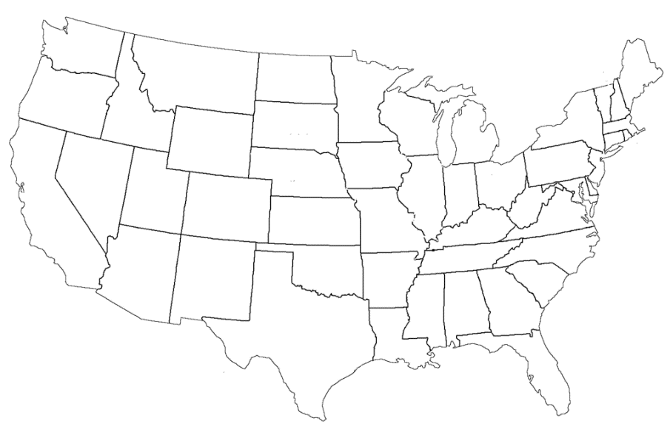

- People who practice the religion of Islam are called ___________________.

- About half of the world’s Muslims live in the Middle East. The other half live in four countries outside the Middle East. What are these countries?

- Complete the table with a summary of each of the 5 pillars of Islam.

Pillar | Summary
1
2
3
4
5

- Give the percentage of each of Islam’s 2 greatest branches: Sunni & Shiite.
Sunni: Shiite:
- In which 4 states are there more Shiite Muslims than Sunni?

- Which European country has the largest Muslim population? Why?

- Where are most Buddhist located?

- Complete the table with a summary of the 4 noble truths.
Noble Truth | Summary
1
2
3
4

- Complete this chart dividing Buddhism into its three main branches.
Branch | % of Population | Regions of Predominance
- Why are Buddhists difficult to count?

- In what 2 states are Hindus concentrated? What percent of all Hindus live there?

- What is unique about what Hindus believe and how they worship? Is there a central book?

- Make a note or two (that seem of geographic interest) about each of the following ethnic religion listed below.
  - Confucianism:

  - Taoism:

  - Primal-Indigenous:

  - Animism:

  - Spiritism:

  - Judaism

Key Issue 2: Why Do Religions Have Different Distributions?
Pages 178-191
- Complete the chart below describing the origins and branches of the major universalizing religions.
 | Buddhism | Christianity | Islam
Year of Origin
Founder
Major Branches & Main Beliefs of Each Branch

- What is Sikhism? What is the Sikhs relationship with Iran?

- The word Hinduism originated in the 6th century B.C. to refer to people now living in ________________.

- What two ancient peoples beliefs blended to form Hinduism?

- Complete the chart to explain the ways that diffusion contributed to the spread of Christianity.

- Which type of diffusion caused the Americas to be mostly Christian? Which places influenced each continent?

- Latter day saints are also known as ___________. The founder of this religion is _______________________.

- Give three ways in which Islam spread. Briefly summarize each.

- Give two reasons for the expansion of Buddhism.

- Provide three examples of cases in which religions, or religious practices, have blended.
Religions Which Have Blended | Location
- How is the distribution of Judaism very different from other ethnic religions?

- How were most Jews treated as they lived among other nationalities? Give an example.

- What is the origin of the term ghetto?

- In which religion are holy place more spread out? Circle one: Ethnic OR Universalizing
- Why? (question 14)

- How are holy places identified/chosen in Buddhism?

- Complete the table to show the holiest places in Islam.
Place: | Why it’s important to Islam:

- Where are many Hindu holy shrines located? One especially body of water is the _____________________.

- Complete the table to explain the unique things about calendar and celebrations in ethic & universalizing religions.
 | Calendar | Celebrations
Ethnic Religions
Universalizing Religions

Key Issue 3: Why Do Religions Organize Space in Distinctive Patterns?
Pages 200-211
- In what two ways do religious structures often stand out in a landscape?

- For what two reasons does a church, the physical structure, play a more critical role than in other religions?

- Why do many Christian churches vary in architectural style?

- How is a Muslim mosque viewed differently than a Christian church?

- Identify four specific, visible features of a typical mosque.
- What is the religious purpose of a Buddhist pagoda?

- How was pilgrimage a part of the development of pagodas?

- Formal worship in a pagoda is not typical. Where does it usually take place?

- What is a pilgrimage?

- Read the section about Holy Places and make notes on three case studies: Buddhism, Islam & Hinduism.
Holy Sites
Buddhist
Islamic
Hindu
- How are Hindu temples different than both churches and mosques?

- List three typical visible features of a Hindu temple.

- Give at least three examples of how religions have incorporated characteristics of cosmology.

- What is the solstice?

- Christian practice burial of the dead. Complete the flow chart below to indicate the history of this practice.

⬇
⬇

- Complete the chart below with brief notes on the disposal of the dead in ways other than burial.
Hindus
Parsis
Micronesia

- Complete the chart below with brief notes on the religious settlements indicated.

Utopian Settlements
Salt Lake City, Utah
Puritans

- Complete the chart below regarding religious calendars.

What is the most prominent feature of the calendar in an ethnic religion? | What is the principle purpose of the calendar in a universalizing religion?

- How is the Jewish calendar typical of the ethnic use of the calendar?

- Both the Jewish and the Muslims use a lunar calendar, yet in a different way and with very different results. Explain.

- How is the date of Easter related to physical geography (the natural world) through the calendar?

- Why do different Christian branches celebrate Easter on different days?

- How is this similar to Buddhism’s major holidays?

- Define hierarchical religion:

- List the Roman Catholic hierarchy, indicating geographic region and leader who heads it.

- Why are parishes in Latin America so much larger than in Europe?

- Describe an autonomous religion:

- In the absence of a hierarchy, what is the only formal organization of territory in Islam?
- What holds Islam together?

- Complete the chart below to categorize other religions and denominations.

Autonomous Religions | Hierarchical Religions

Key Issue 4: Why Do Territorial Conflicts Arise Among Religious Groups?
Pages 212-221
- In what ways did the Taliban government of Afghanistan raise conflicts with Western/modern ideas after it took control of the country in 1996?

- What aspect of Hinduism has clashed with Western/modern ideas?

- What western groups criticized this aspect? Why?

- How has the Indian government responded to this issue?

- In Russia/Soviet Union, how did each of the following attempt to limit the influence of religion, specifically the Eastern Orthodox Church?
Czar Peter the Great:

Communism:

- What happened, and is continuing to happen, in each of the following regions of the Russian Empire/Soviet Union since the fall of Communism in the 1990s? Complete the chart below by adding THREE more countries to each category and then describing what is going on at the present time in that region.

Historic Catholic Regions | Historic Muslim Regions
Croatia, Czech Republic, Hungary, Lithuania, … | Kazakhstan, Kyrgyzstan, …
Currently… | Currently…

- How was the Vietnam War detrimental to Buddhism in Southeast Asia?

- How were Communist regimes detrimental to Buddhism in Southeast Asia?

- Define fundamentalism (You may have to look this up)

- What are two religious groups in conflict in Ireland?

- Where are the majority of these groups located?

- What three religions are in constant conflict over the land in the Middle East?

- What was the military campaign by the Christians to recapture their Holy Land from the Muslims?

- Complete the chart below regarding the perspective on the Holy Land.

Palestinian Perspective | Israeli Perspective

- Complete the chart below regarding Jerusalem

Judaism’s Jerusalem | Islam’s Jerusalem

