Key Issue 1: Where Are Languages Distributed?
Pages 142-149

***Always keep your key term packet out whenever you take notes from Rubenstein. As the terms come up in the text, think through the significance of the term.
- Define language:

- Define official language:

- Define language family:

- Define language branch:

- Define language group:

- Make brief notes on each of the following language families as you read about them in this section (i.e. how many people speak a language of that family, where spoken, common languages, etc.). See pages 146-149.

  - Indo-European

  - Sino-Tibetan

  - Austronesian

  - Austro-Asiatic

  - Tai Kadai

  - Japanese

  - Korean

  - Afro-Asiatic

  - Altaic

  - Uralic

  - Niger-Congo

  - Nilo-Saharan

  - Khoisan

Key Issue 2: Why is English Related to Other Languages?
Pages 150-157
- Using the reading on page 150, complete the following chart about the Germanic Language Branch
Germanic Branch
West Germanic Group | North Germanic Group
⬇  ⬇

- Indo-Iranian Branch: Make 2 bullets charts from the reading.
Indic Group (Eastern) | Iranian Group (Western)

- How did Russian become the most important East Slavic language?

- What is the most important West Slavic language?

- Describe the controversy between Czech and Slovak languages under Czechoslovakia’s government? What happened?

- Why are South Slavic languages, which were once very similar to each other, becoming increasingly different today?

- The four most contemporary Romance languages are _________________________, ________________________, _________________________ & ______________________________.

- How did English become widely diffused?

- What three European people originally came together to form the English people and English language?

- Where did these people come from?

- What two subsequent invasions added additional words to the evolving English language?

- When and why did English diffuse to North America?

- How did Latin languages diffuse in Europe? What happened to the native languages?

- Define Vulgar Latin:

- What is the name of the (theoretical) common ancestral language of all languages discussed in this key issue of the chapter?

- Why is its existence difficult (impossible) to prove?

- Contrast the two views of the origin of this language in the chart below.

“Kurgan” Theory | Renfrew Hypothesis

Key Issue 3: Why Do Individual Languages Vary Among Places?
Pages 151-156

- Use the classification of languages on page #151 to draw a pie chart below. Label each section with the language family, language example, and percent of the world population.

- List the following terms from largest number of people within the group, to smallest number of people within the group: Language family, Language branch, Language family, Language group.

SINO-TIBETAN LANGUAGE FAMILY
- Where is language in the Sino-Tibetan family generally spoken?

- Mandarin Chinese is also known as what?

- In what 3 places or organizations is mandarin the “official language”?

- What is the difference between how the word are written and how the words are pronounced?

- What is the structure of the Chinese languages?

- What is the main language problem for the language group?

EAST & SOUTHEAST ASIAN LANGUAGE FAMILIES
- Complete the table as you read through pages 152-154 to describe the various language families.
Language | Where? | Written language? | What’s Unique?
Austroneasian
Austro-Asiatic
Tai Kadai
Japanese
Korean

LANGUAGES OF THE MIDDLE EAST & CENTRAL ASIA
- Complete the table as you read through pages 154-156 and describe the various language groups.
Language | Where? | Written Language? | Origins? | What’s Unique?
Afro-Asiatic
Altaic
Uralic

AFRICAN LANGUAGE FAMILIES
- How many distinct African languages have been recorded?

- What language dominates in Northern Africa? Based on class, why do you think this might have occurred?

- Complete the table as you read page 156 and describe the various language groups.
Language | Where? | Problems/Regional communication? | Unique?
Niger-Congo
Nilo-Saharan
Khoisan

Key Issue 4: Why do People Preserve Local Languages?
Pages 156-164
- What two competing geographic trends are shown by the diversity/spread of language?

- Label the world map below to show the number of “nearly extinct” languages in the world today.
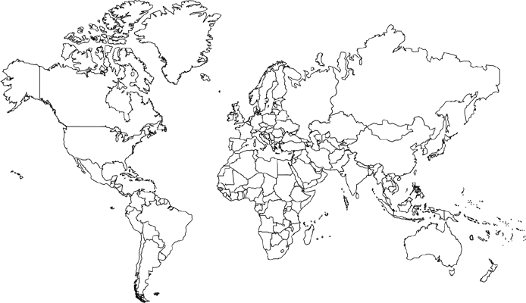

- ________________ is an indigenous language in Peru spoken by more than 1 million people.

- Where was the gothic language spoken? Where did the last known speakers of the gothic language live?

Why did the gothic language die? | Why are indigenous languages dying?

- Why was Hebrew chosen to be one of the official languages of Israel in 1948?

- Why was is hard to revive Hebrew?
- The survival of any language depends on the _______________ and _________________ military strength of its speakers.

- Why did the Celtic languages decline?

- Explain how parents and teachers encouraged children to learn the language of their English or French Conquerors.

In Wales, in what ways is welsh being preserved? | In what ways is Irish being preserved?

- In Belgium the Flemings speak ____________, and the Walloons speak ____________.
- Explain problems in Belgium caused by the language boundary.

- Switzerland has 4 official languages; what are they?

- Why can Switzerland function and peacefully exist as a country with multiple languages?

- Define “isolated language”. Where is Basque spoken?

- If a Polish airline pilot flies over Spain, what language does the pilot speak to the traffic controller in Spain? What phenomenon does this represent about English?

- Define “Lingua Franca”?
- Define “pidgin language”?

- Why do recent changes in English represent a unique form of expansion diffusion?

- Define “Ebonics”?

- Why are Ebonics & Appalachian dialects controversial?

- What is “Denglish”?

- Draw (& label) the language tree using the following guidelines below. Use page #155 as an example.
Hierarchy of languages: Family>>>Branch>>>Group>>Language>>Dialect
(Trunk) (Branch) (Twig) (Leaf) (Vein divisions)

