Key Issue 1: Where Are Migrants Distributed?
Pages 80-85

- Most people primarily migrate for ____________________ reasons.
- Define a push migration factor & a pull migration factor.

- List a few push and pull factors for each category in the table below.
 | PUSH | PULL
ECONOMIC
CULTURAL
ENVIRONMENTAL

- What is an intervening obstacle? What was a major obstacle for Europeans coming to the North American continent?

- Before the invention of vehicles and airplanes, where were intervening obstacles for people migrating across land masses.

- Migration may be classified as either international or internal. What is the difference?

- What is INTRAregional migration and what has it historically been?

- International migration (emigration) occurs mostly from countries in stage ________ of the DTM. While internal migration occurs from countries in stages _______ & _________.
- According to Ravenstein, most long distant migrants are male & single adults. Why? (Explain)

- What caused immigration from Latin America to the United States to increase?

Key Issue 3: Why Do Migrants Face Obstacles?
Pages 92-95

- Traditionally immigrants from other countries faced intervening obstacles that were environmental such as _______________________________________. However the two major obstacles that face migrants now are cultural, namely: __________________________________ and ________________ ___________________.

- What did the Quota Act (1921) and the National Origins Act (1924) do?

- How did they favor immigration from certain regions?

- How did the Immigration Act of 1965 change the existing quota laws?

- How was the immigration law further changed in 1978?

- U.S. immigration law gives preferences to groups. Identify those preferences.

- Define brain drain:

- What are guest workers?

- Complete the table about guest workers:

BENEFITS TO WESTERN EUROPE | BENEFITS TO POORER COUNTRIES
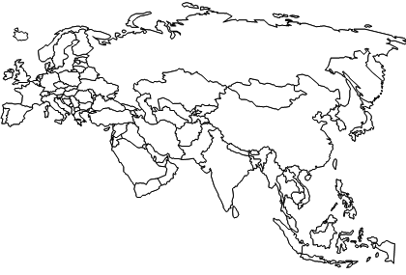
- Using the map below: Shade or circle the regions that most European guest workers come from. & draw arrows to western Europe.

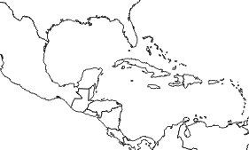

11. Using the maps above & to the left, shade Vietnam, Cuba, and Haiti. Then complete the table below.

 | CUBA | HAITI | VIETNAM
Year?
What were the push Factors?
Admitted?(yes/no)
Explain:
Key Issue 4: Why Do People Migrate Within a Country?
Pages 95-100
- Traditionally regional migration occurred when people were in search of better __________________. However now most interregional migration is from _________________________________ to __________________________________ because of job opportunities.
- What is the most famous example of large-scale interregional migration in the U.S.?

- Complete the timeline below to discuss migration in the United States. Include the date on the left hand side.
Why did people go? (push/pull) | What made settlement possible? (transport/technology)

- Use the chart on page 97 to calculate the net growth or loss of U.S. regions for 2010. Name the region on the map and place the appropriate number in each region.
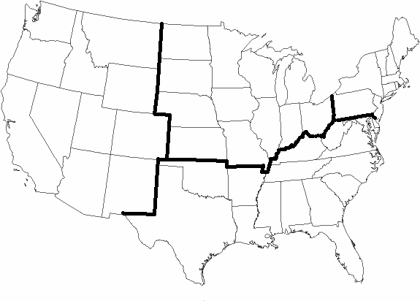

**** SKIP Pgs. 97-98 ***

- Define/describe each of the following terms, and summarize a single, important fact about its occurrence in the U.S.
 | Urbanization | Suburbanization | Counterurbanization
Explain concept:
Major regions & reasons

