Chapter 13 Learning Guide – Urban Patterns

Key Issue 1 – Why Do Services Cluster Downtown?
Pgs. 406 - 410

CBD Land Uses

- Define the term CBD in one word.

- List four (4) characteristics of a typical CBD.

Using your knowledge of services from chapter 12, define each term and give an example of a typical downtown shop with that characteristic.

- High Threshold

- High Range

- Why are these shops decreasing in the CBD?

- Another type of shop in the CBD are those which provide services to downtown workers. Gove three (3) examples.

- Why are these shops increasing?

- Other types of businesses locate in CBDs because workers require face-to-face contact with other workers. Give two (2) examples of these types of businesses.

Competition for Land in the CBD

- Describe how the intense land use of CBDs has created expansion of the CBD “above” and “below” in order to maximize the small space of the downtown?

- How is “land use” distributed within a typical skyscraper?

- What is the only major U.S. city without skyscrapers?

- _________________________________ and __________________________________ discourage
_________________________________and ___________________________________ in the CBD.

- What is happening to the old manufacturing districts in American CBDs?

- Regarding residential uses – identify a factor pushing them out of the CBD and another that is pulling them elsewhere.

Pushing… | Pulling…

CBDs Outside North America

- List five (5) ways that a European CBD differs from a North American CBD.

Chapter 13 Learning Guide – Urban Patterns

Key Issue 2 – Where Are People Distributed Within Urban Areas
Pgs. 410 - 418

Models of Urban Structure

1. Read the following section of this key issue and for each of the three models, annotate the diagrams below and do the following:

- Identify the model by name
- Name the geographer(2) who developed the model
- Define the model
- Identify and label key parts of the model
- Bullet important characteristics and/or features of the model

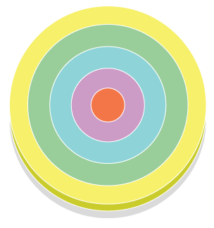

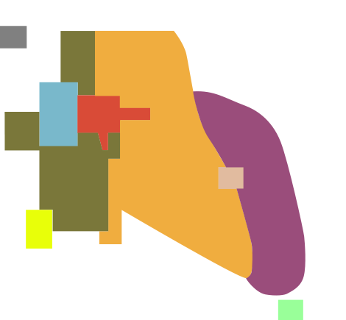

2. What are census tracts?

3. What three (3) types of data are reported by the U.S. Census Bureau regarding the population of each census tract?

4. What is social area analysis?

- What two (2) things can we deduce by combining all three models rather than considering them independently?

Applying the Models Outside North America

- What are the advantages of living in the inner-ring near the city center?

- List three (3) points about the conditions of European suburbs, where the poor live.

- Cities in Africa, Asia and Latin America resemble European cities in their structure. This is not a coincidence because….

- Draw and label a sketch of a “pre-colonial city”

- Colonial cities often contained a new “European sector” to the side of the pre-colonial city. Contrast their various elements in the table below.

“Old Quarters” – pre-colonial city | “European district” – colonial addition

- Describe the elite spine sector developed in Latin American cities.

- What are the causes of squatter settlement?

- Define squatter settlements.

14. Describe services and amenities in a typical squatter settlement.

- Make a simple flowchart which depicts stages in the development of a squatter settlement.

Chapter 13 Learning Guide – Urban Patterns

Key Issue 3 – Why Do Inner Cities Have Distinctive Problems?
Pgs. 418 – 423

- Complete this statement regarding the basic problems of the inner city:

“Inner cities in the United States contain concentrations of _______________________ people with a variety of physical, _____________________, and _________________________ problems very different from those faced by __________________________ residents.”

Inner City Physical Issues

- What is the major problem faced by inner-city residents?

- Describe the inner-city process known as filtering.

- What is the ultimate result of this process?

- What is redlining and its result?

- What is urban renewal?

- Why has urban renewal been criticized?

- Complete the chart below regarding public housing.

Public Housing
Who builds & maintains it?
Percentage in the U.S.
Reasons high-rise public housing is unsatisfactory
How are recent public housing projects different?

- Define gentrification:

- What three (3) groups are attracted to gentrified areas and why?

- Why has gentrification been criticized?

Inner-City Social Issues

- Complete the statement regarding the population in the inner-city:

“Inner-city residents frequently are referred to as a permanent ____________________ because they are _______________________ in an unending ____________________ of economic and social _________________________.”

- List and briefly describe four (4) specific social problems of the underclass.

Inner-City Economic Issues

- What financial crisis does the high proportion of low-income residents in the inner city create?

- Explain the two (2) choices a city has in order to solve this problem.

- What two (2) things are happening to homeowners who have been unable to repay their subprime loans?

Chapter 13 Learning Guide – Urban Patterns

Key Issue 4 – Why Do Suburbs Face Distinctive Challenges?
Pgs. 424 – 434

Urban Expansion

- What is annexation?

- What is required before an area can be annexed by a city?

- In the past, why did peripheral areas desire annexation?

- What has changed?

- Define city:

- What are the three (3) basic characteristics of a city?

- Define urbanized area:

- What is the functional area of a city?

- What does the MSA include?

- Define council of government:

- What is a Megalopolis?

- What is the Megalopolis from Boston to D.C. called?

The Peripheral Model

- List the elements of an urban area according to the peripheral model.

- Complete the table below regarding peripheral areas.

Problems They Lack | Problems They Have

- Define edge city:

- Describe the density gradient of an urban area.

- In what two (2) ways has the density gradient changed in recent years?

- Define sprawl:

- What is meant by the statement: the “periphery of U.S. cities looks like Swiss cheese”?

- What has prevented the peripheries of European cities from looking like Swiss cheese?

- What is smart growth?

- Describe how “smart growth” laws have been designed in the following states?

Maryland | Oregon & Tennessee

Suburban Segregation

- In what two (2) ways are suburban areas segregated?

- What is a zoning ordinance?

- What is the strongest criticism of U.S. suburbs?

Transportation & Suburbanization

- Fill in the flow chart describing how developments in transportation affected the residential pattern of American cities.

Pedestrian Phase |  | Streetcar Phase |  | Automobile Phase

- Identify two (2) ways in which the U.S. Government has encouraged the use of motor vehicles by its citizens.

- What is rush hour and how much of a city’s traffic does it account for?

- List four (4) ways in which public transportation is better than an automobile.

- Briefly describe what has happened (or is happening) to each of the following modes of public transportation in U.S. cities.

Trolleys
Buses
Rapid Transit (subway & fixed rail line)

