**KEY ISSUE #1: Where Did Agriculture Originate?**

**Pg. 308-314**

**1. Define *agriculture*:**

**2. Use the following table to take notes on Hunter/Gatherer societies.**

|  |  |  |  |  |
| --- | --- | --- | --- | --- |
| Why are groups only up to 50 people? | What are the men responsible for? | What are the women responsible for? | How long does it take to find food? | Why do groups move so often? |
|  |  |  |  |  |

**3. How many hunter-gatherers are there today & where do they live?**

**4. Explain the two arguments about why agriculture originated.**

**5. Read the “Subsistence and Commercial” section of the chapter and complete the table below with important information. The text will generally explain commercial agriculture and you will need to hypothesize the situation for subsistence agriculture.**

|  |  |  |
| --- | --- | --- |
|  | **Subsistence Farming (mostly in LDC’s)** | **Commercial Farming (mostly in MDC’s)** |
| **Purpose of farming** |  |  |
| **% of farmers in the labor force** |  |  |
| **Use of machinery** |  |  |
| **Farm size** |  |  |
| **Relationship of farming to other business** |  |  |

**6. Define *agribusiness*:**

**KEY ISSUE #2: Where Are Agriculture Regions in LDC?**

**Pg. 314-322**

**1. What are two characteristics of shifting cultivation?**

**2. What climate is shifting cultivation usually practiced in?**

**3. What is *“swidden”?***

**4. What tools are usually used?**

**5. What is *“potash”?***

**6. How long are swidden’s usually used? Why?**

**7. CASE STUDY: A Kayapo swidden field in Brazil’s Amazon region.**

**Draw a labeled diagram below to explain the description given in the text.**

|  |
| --- |
|  |

**8. How is land owned in a typical village that practices shifting cultivation?**

**9. About _______ % of the world’s land area is devoted to shifting cultivation, but less than ________ % of the world’s population practices shifting agriculture.**

**10. Complete the table below with the pros & cons of shifting agriculture**



**11. P*astoral nomadism* is a form of subsistence agriculture based on the *_________________________________­__ _______________________________________________________* and it is generally found in *___________* climates.**

**12. What do pastoral nomads depend on to survive? What does this provide them?**

**13. What is the relationship between a pastoral nomad group and their animals?**

**14. What animals are chosen, why, and where?**

**15. Why is territory important in pastoral nomadism?**

**16. What is *transhumance*?**

**17. In what ways is pastoral nomadism currently threatened by modern governments?**

**18. What is meant by “intensive”?**

**19. Where is intensive subsistence agriculture practiced? Why there?**

**20. What is “wet rice” and where is it grown?**

**21. What is a “sawah”? a “paddy”?**

**22. Use the table below to explain how rice is harvested.**

|  |  |  |  |
| --- | --- | --- | --- |
| **Rice plants are harvested by ___________.** | **To separate the seeds, the heads are threshed by _______________________**  **_______________________**  **______________________.** | **Rice that is sold commercially (in a global market) is generally**  **_______________________**  **_______________________**  **______________________.** |  |

**23. In areas of intensive subsistence agriculture where wet rice is not dominant, what are is the major crops?**

**24. Are plantation farms a form of subsistence or a form of commercial agriculture? (Circle one)**

**25. Do plantations produce crops generally for MDC’s or LDC’s? (Circle one)**

**26. Use the table to show where plantation crops are grown.**

|  |  |  |
| --- | --- | --- |
| Latin America | Asia | Crops that can only be grown 1 time per year (generally less likely to be grown in these larger regions) |
|  |  |  |

**27. What is unique about plantation labor (workers)?**

**28. Describe how industrialization (better machinery/technology) impacted cotton harvest in the late 1700’s.**

**KEY ISSUE #3: Where Are Agriculture Regions in LDC?**

**Pg. 322-328**

**1. Where is mixed crop and livestock farming common?**

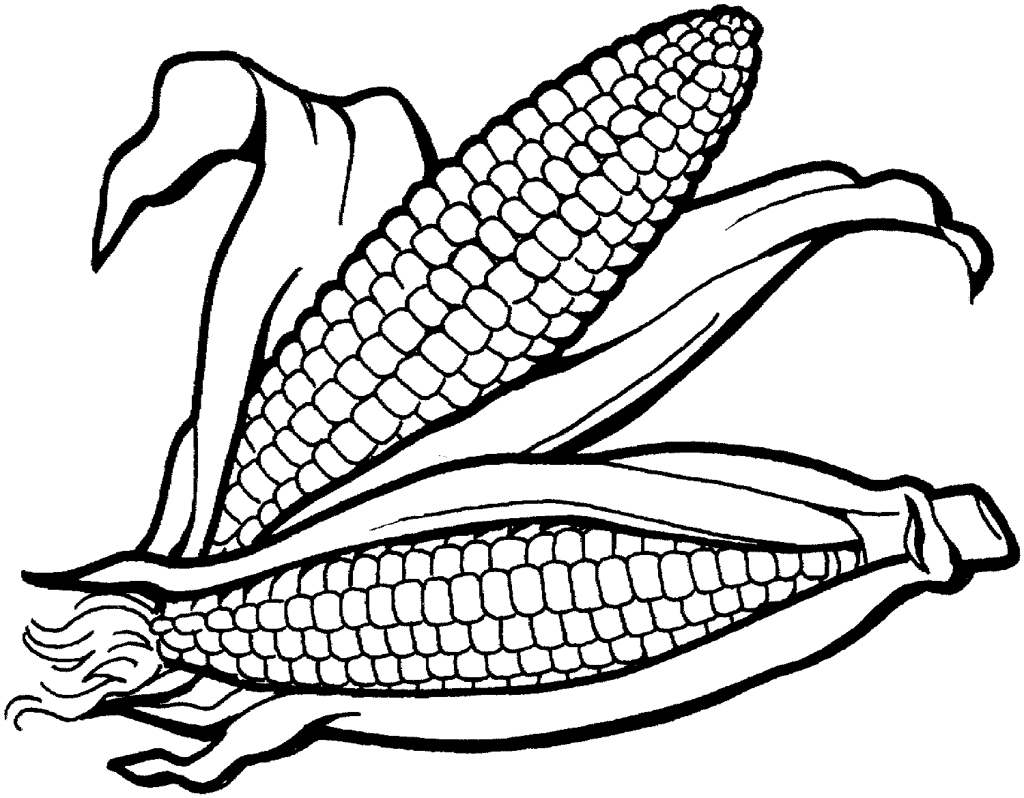

**2. Describe the space/profit relationship between crops and livestock in this model.**

**3. How does this type of agriculture allow farmers to more evenly “distribute their workload”?**

**5. What crop is most commonly planted using mixed crop farming? Where is the US Corn Belt and what crop is becoming second most popular?**

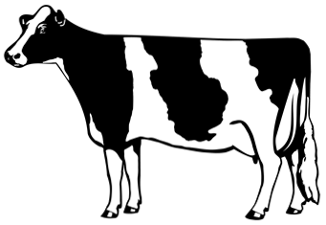

**6. Where is dairy farming common?**

**7. What factor caused dairy farms to traditionally be located outside of the first ring of civilization in MDC’s (the *milkshed*)? What technological advancements after the 1840’s allowed milk to be more than 300 miles away from cities?**

**8. Why do some remote farm regions specialize in “milk products” like cheese and butter rather than fluid milk? What is an example?**

**9. What two problems do dairy farmers currently face?**

* **.**

**10. What is the difference between grains grown in “commercial” regions and “mixed crop /livestock” regions?**

**11. Make a bulleted list to answer the following question: “Why is wheat the most important crop grown?”**

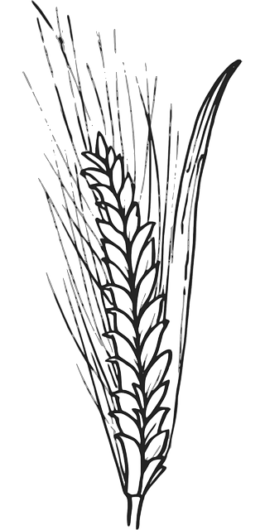

**12. Why can wheat farmers still make a profit, even though what farms are located far away from cities?**

**13. Using the following table, list the states that grow each type of wheat.**

|  |  |
| --- | --- |
| **Winter-Wheat** | **Spring-Wheat** |
|  |  |

**12. How do farmers make use of the fact that the wheat matures at different times in the spring/winter belts?**

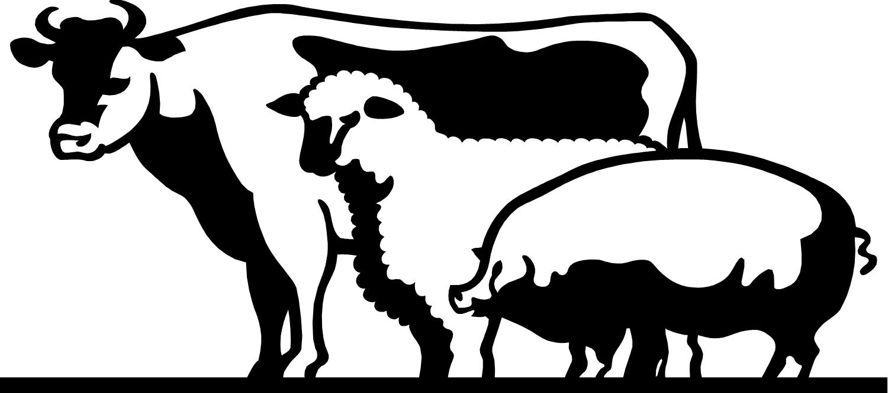

**14. Describe the “stages” of ranching as it has evolved in the US (and very similarly elsewhere) in the chart below.**



**15. Make brief notes to describe the following:**



**16. Most crops in Mediterranean lands are grown for _____________ __________________ rather than for ____________________ ___________.**

**17. Horticulture is the base of Mediterranean farming. What is *horticulture*?**

**18. What are the two most important cash crops of Mediterranean regions.**

**19. Describe the role (and changing role) of California in Mediterranean agriculture.**

**20. What three conditions make the US southeast an ideal location for this type of agriculture?**

**21. List the three ways that truck farmers keep labor costs low.**

* **.**
* **.**
* **.**

**28. What is “specialty farming” and where has it spread in the US?**

**KEY ISSUE #4: Why do Farmers Face Economic Difficulties?**

**Pg.**

1. **How have efficient agricultural practices, fertilizers, and mechanical equipment, etc. created a problem for commercial farmers?**
2. **Make a bulleted list of current ways that the government deals with excess agricultural capacifty (too many crops). Use the section “U.S. Government policies” (pg. )**
3. **What are the two main practices that distinguish farmers practicing sustainable agriculture from conventional agriculture?**

|  |  |
| --- | --- |
| **#1** | **#2** |
| **List 3 advantages or *Ridge Tillage*.** | **In what ways are animals treated differently in sustainable agriculture?** |

1. **The Boserup Thesis considered a change in land use among shifting cultivators that could be described as ________________________. What is basically happening?**



1. **How does the increasing population play both a negative and positive role?**
2. **What is the dilemma (problem) faced by most LDS’s as they seek to increase the amount of export crops to sell to MDC’s?**
3. **Some LDC’s turn to the production of drug crops for export. The geography of these crops is unique. Identify the countries associated with the crops below?**

|  |  |
| --- | --- |
| **Coca Leaf** |  |
| **Marijuana** |  |
| **Opium** |  |

**8.**



**9. Make a list of the 3 reasons that agricultural land is currently being removed from agricultural use.**

**10. The two main practices of the Green Revolution are ______________________ & ______________________.**

**11. Because of the Green Revolution, agricultural productivity at a global scale has ________________**

**_______________ than ________________ _________________.**

**12. Use the table below to describe the “Miracle Seeds”.**

|  |  |
| --- | --- |
| **MIRACLE WHEAT SEED** | **MIRACLE RICE SEED** |
|  |  |

**13. What specific problems do farmers in LDC’s have which might prevent them from taking full advantage of**

**the green revolution?**

**14. Use the chart below to list & describe one problem with each of the strategies for increasing the world’s supply by identifying new food sources.**

|  |  |
| --- | --- |
| **Strategy** | **Problem** |
| **#1** |  |
| **#2** |  |
| **#3** |  |

**15. What are the top export grains in the world?**

**16. Use the map below to label and shade the 5 largest grain importing AND exporting countries.**

