Key Issue 1: Where is the World’s Population Distributed?
Pages 46-50

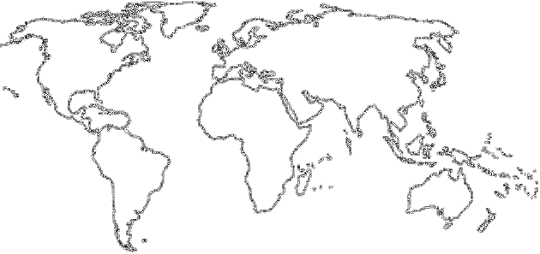
- FOUR major population concentrations are identified in the text. Shade and label the areas of these concentrations on the map in one color. TWO smaller concentrations, or emerging clusters, are also identified. Shade and label these areas on the map in another color.

- In the boxes below, make note of significant facts involved, and characteristics of the four most important population concentrations. Include % of world population & most significant countries within region.
EAST ASIA | SOUTH ASIA
SOUTHEAST ASIA | EUROPE

- Define ecumene:

- In the table below, list the four “lands” which are sparsely populated on earth. For each region, explain the reason which makes it inhospitable for human habitation.
Sparsely Populated Land | Reason(s) for Inhospitality
Dry Lands

Wet Lands

Cold Lands

High Lands

- Take a few notes on specific countries & cities with high arithmetic densities.

- What occurs when the rate of physiological density increases?

7. Why is it helpful to compare arithmetic & physiological densities (what does it tell us/predict)?

Key Issue 2: Why Has the World’s Population Increased?
Pages 53-55
- Define crude birth rate (CBR):

- Define crude death rate (CDR):

- Define natural increase rate (NIR):

- What is the NIR today? When did the global NIR peak, and what was it?

- About how many people are being added to the world’s population each year?

- Define doubling time:

- In what world regions is most growth occurring?

- Define total fertility rate (TFR):

- What is the global “average” TFR? Where are the highest TFR’?

Key Issue 3: Why is Population Increasing at Different Rates in Different Countries?
Pages 56-66

- The demographic transition is a ________________________ with several

___________________ and every __________________________ is in one of the stages.
- Historically people have moved…

*** SKIP READING PGS: 56-58 *** (I will explain this section in class)
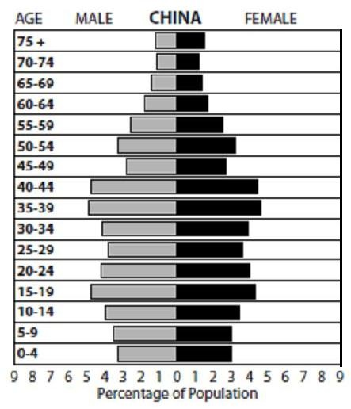
- What is the shape of a population pyramid primarily determined by?

- Sketch a pyramid with a low birth rate.

- What is the dependency ratio? What age groups are categorized as “dependent”?

- How are the people within the dependency ration different in Europe compared to Africa?

- What is the sex ratio?

- What types of countries/regions are likely to have more males than females? Why?

- In the chart below, which represents the four stages of demographic transition, identify the country and where it is located which is in that stage and briefly describe how it got to that stage. Use the DTM samples and population pyramids on pages 61-64 to help you with this.

Stages of the Demographic Transition Model
Stage 1 | Stage 2 | Stage 3 | Stage 4
No country in stage 1

- In what sense can we say that the first break came to different world regions for different reasons and in different ways?
  - It came to Europe and North America…

  - It came to Africa, Asia, and Latin America…

- The CBR has declined rapidly since 1990. Identify the two strategies that have been successful in reducing birth rates and explain why they have been successful.

- Complete the table below to describe the views/theories of various population theorists:
Thomas Malthus | Neo-Malthusians | Critics of Malthus

- Where has Malthus’s theory proven right?

- In what ways was Malthus mistaken?

- Examine Japan’s population:
  - How is Japan’s population expected to change by 2050?

  - Why is this expected to happen?

  - Why is it problematic for Japan?

- Identify the two “big breaks” in the demographic transition and their causes.
  - The first break…

  - The second break…

- What would characterize a possible stage 5 of the DTM?

- In the chart below, summarize/bullet key points of India’s and China’s population policies
India | China
Key Issue 4: Why Do Some Regions Face Health Threats?
Pages 64-73

- What is epidemiologic transition?

- Complete the table below with notes on the stages of epidemiologic transition:

Stage 1 | Stage 2 | Stage 3 | Stage 4 | Possible Stage 5

- Two important indicators of health in a country are infant mortality rate (IMR) and life expectancy.
  - Define infant mortality rate:

  - Define life expectancy:

- How are these mortality rates distributed globally, in terms of the developed and developing worlds?

- Compare and contrast reasons for variations in health care between developed and developing countries.

