Stop using the word "Caucasian" to mean white
By Razib Khan | January 22, 2011 10:34 am
About four years ago blogger emeritus RPM of evolgen brought into sharp relief an issue which has nagged me:
Caucasian, literally, refers to people native to the Caucasus, but it has become interchangeable with any number of ‘White’ populations, most of wh1om trace their ancestry to Europe. One gets the feeling that the term ‘White’ fell out of favor and was replaced by ‘Caucasian’ much like ‘Black’ was replaced by ‘African-American’. But the roots of such terminology are a bit disturbing; it was postulated that the natives of the Caucasus exhibited the idealized physical appearance so the Caucasus were believed to be the birthplace of mankind. The logic behind this idea — the assumption that Whites exhibit the best physical appearance — is implicitly racist. Additionally, we now know our species first appeared in Africa, so the biology isn’t any good either. The connotations of the term Caucasian along with the geographical absurdity of using that term to describe all Europeans or Whites are the two main reasons we should abandon the term.
Up until the late 1990s I had thought of people from the Caucasus mountains when I heard the term, but then I began to reorient my assumption because of its colloquial usage. But as it became more and more popular I got more irritated, because it became obvious that the type of people who now were using the term likely did not know where the Caucasus mountains were. With Ngram Viewer you can check the patterns of popularity over time:
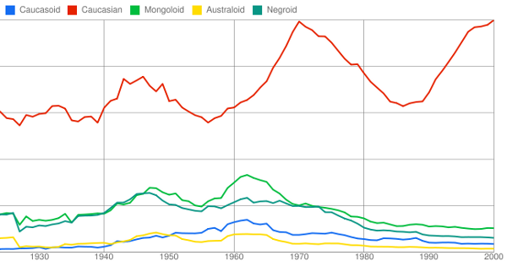
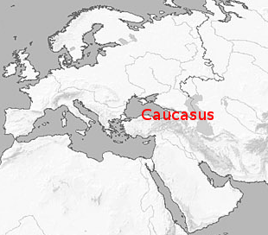
While the older classical physical anthropology terms like “Negroid” and “Caucasoid” fell into disuse after 1960, as you’d expect, “Caucasian” went through a renaissance in the 1990s. I think RPM’s supposition is probably correct, people wanted a pretentious term somewhat less coarse than white, and since most people are geography-challenged, “Caucasian” sounds good, simply put.The Caucasus mountains bound the Middle East on the north, and the real Caucasians are to some extent a liminal Middle Eastern population.
This gets really dumbfounding for the people who ask and answer questions of the form “are Armenians white?” on the internet. After all, the Armenians are indubitably Caucasian, and Caucasian is white, right? Compare the subtly of a regular dictionary definition of Caucasian, to the straightforward acknowledgement of the idiocy of the common usage of the term in urban dictionary.
This matters to me in a concrete manner. In my post on Assyrians below I avoided the term “Caucasian,” because I didn’t want to confuse people. But this is getting ridiculous. I now believe that a population movement from the trans-Caucasian region due to demographic expansion has probably had a major impact on both Europe and South Asia. But I’ve been avoiding terming these people “Caucasians,” lest I just muddy the waters because of the disjunction between colloquial usage and coherency. But that’s what people from the Caucasus are! So I’m changing my practice, and using the term as I really want to use it. If people get confused, and they show up in the comments, I will “correct” them as I’m wont to do. For those readers who have qualms about the coarseness of “white,” and the genericness of “European, how about the term “Aryanoids”? It will still make you sound smarter to the herd. And, it’s just as stupid and also derived from a scientific tradition which is in disrepute. But it has the convenience that it doesn’t correspond to anything real in this world.
Answer the following questions based on the article:
1. What is the term “Caucasian” traditionally used to refer to? What does the term “really” mean?

2. What term was used to refer to white people before the 1960’s?

3. What does it mean that the term “Caucasian went through a renaissance in the 1990’s”?

4. Where are the Caucasus Mountains?

