The Scramble for Africa: Berlin Conference of 1884-1885
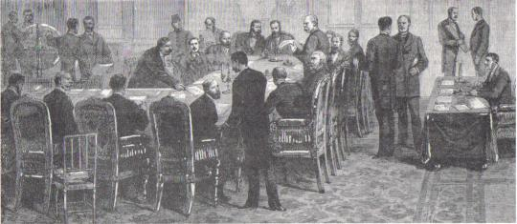

In the second half of the nineteenth century, after more than four centuries of contact, the Western European powers finally laid claim to virtually all of Africa.

Between the late 1400s and 1700s, Western Europeans had traveled along the African coastline in search of gold and slaves for their American colonies, but rarely traveled into Africa’s interior. By the mid-1800s, parts of the African continent had been "explored," but now representatives of European governments and rulers arrived to create or expand their control over African lands. Competition by Western European nations was intense. Spheres of influence [an area of land where a foreign nation has overwhelming political and economic power] began to crowd each other. It was time for negotiation in order to avoid war between these competing European nations in Africa. In late 1884, a conference was convened in Berlin to sort things out. The Berlin Conference laid the groundwork for the now familiar political map of Africa.

In November 1884, the imperial chancellor and founder of the German Empire, Otto von Bismarck, organized a conference of 14 nations (including the United States) to settle the political partitioning [division] of Africa. Bismarck wanted not only to expand German spheres of influence in Africa but also to play Germany's colonial rivals against one another to the Germans' advantage. Of these fourteen nations, France, Germany, Great Britain, and Portugal were the major players in the conference, controlling most of colonial Africa at the time. No African ruler was invited to attend these meetings, yet the conference sealed Africa’s fate. The European nations carved Africa up into colonies with little thought about how African ethnic or linguistic groups were distributed. The participants in the conference saw Africa as a blank map that was theirs for the taking.

The Berlin Conference was Africa's undoing in more ways than one. The Western European nations covered the African continent with their colonies. In fact, by 1914, the only independent nations in Africa were Ethiopia and Liberia. By the time Africa regained its independence after the late 1950s, Africa had acquired a legacy of political fragmentation [division] that could neither be eliminated nor made to operate satisfactorily. The African political map is thus a permanent liability that resulted from the three months of ignorant greed during a period when Europe's search for raw materials and markets to sell goods had become limitless.

More immediately, however, the Berlin Conference resulted in the French dominating most of West Africa, and the British dominating East and Southern Africa. The Belgians acquired the vast territory that became The Congo. The Germans held four colonies. The Portuguese held a small colony in West Africa and two large ones in Southern Africa.
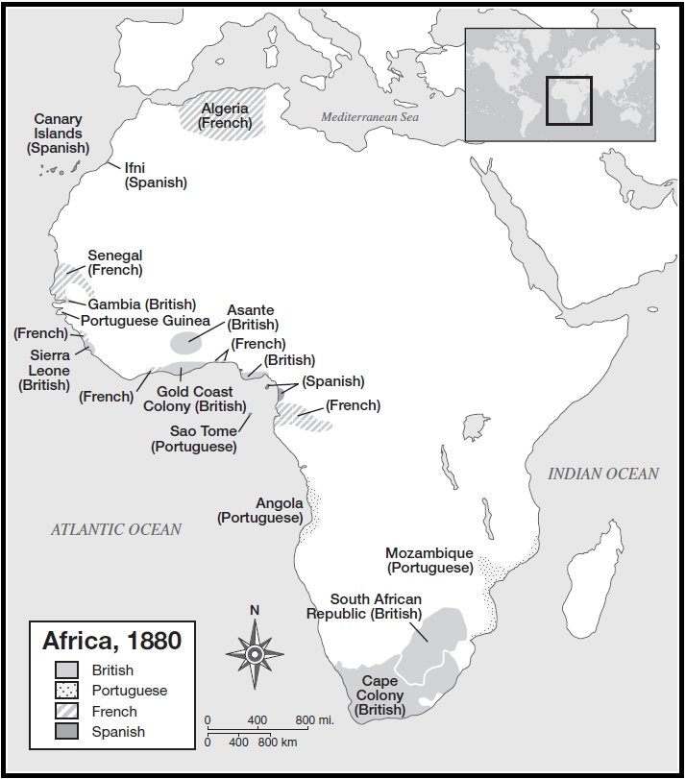
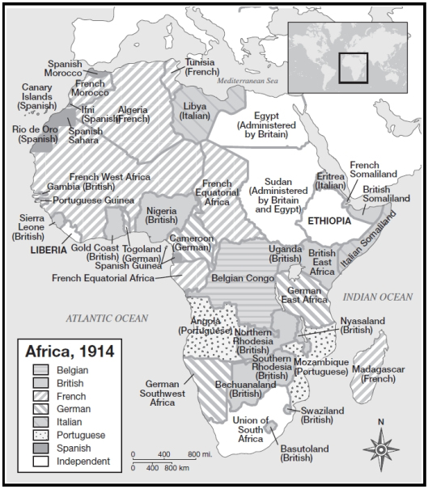
AFRICA AFTER THE BERLIN CONFERENCE
AFRICA BEFORE THE BERLIN CONFERENCE

QUESTIONS FOR ANALYSIS

- Why was the Berlin Conference convened?

- In what ways was the Berlin Conference extremely unfair for Africans?

- What happened to the continent of Africa as a result of the Berlin Conference?

- Which European nations dominated most of Africa between 1884 and the 1950s?

